Athena Swan renewal application form for departments

Applicant information
Name of institution | University of Oxford
Name of department | Psychiatry
Date of current application | 31st March 2024
Level of previous award | Silver
Date of previous award | May 2018

Table of Contents
Applicant information 1
Section 1: An overview of the department and its approach to gender equality 4
1. Letter of endorsement from the head of the department 4
2. Description of the department and its context 5
3. Athena Swan self-assessment process 14
Section 2: An evaluation of the department’s progress and issues 18
1. Evaluating progress against the previous action plan 18
2. Key priorities for future action 24
Section 3: Future action plan 61
1. Action plan 61
Appendix 1: Culture survey data 86
Appendix 2: Data tables 86
Appendix 3: Glossary 117

Section 1: An overview of the department and its approach to gender equality
In Section 1, applicants should evidence how they meet Criterion A:
- Structures and processes are in place to underpin and recognise gender equality work
Recommended word count: 2500 words

1. Letter of endorsement from the head of the department
Please insert (with appropriate letterhead) a signed letter of endorsement from the head of the department.


DEPARTMENT OF PSYCHIATRY
WARNEFORD HOSPITAL
OXFORD
OX3 7JX
Professor Belinda Lennox
Head of Department
Tel: +44 (0)1865 618201
Email: belinda.lennox@psych.ox.ac.uk

Dear Committee,

I am delighted to endorse our application for renewal of our Athena swan Silver Award. As Head of Department of Psychiatry since 2022, my key strategic priority has always been our culture – working to make Psychiatry an inclusive, diverse and welcoming department.

One of my first actions was to appoint an Associate Head of Department for People and Culture, Professor Catherine Harmer. She chairs the monthly People and Culture oversight committee, which includes representation from several working groups in the department, including the Athena swan working group chaired by Dr Laura Winchester. Our work for Athena swan has been ongoing and embedded throughout our activities and governance structure, with presentations at departmental away days, as part of our research meeting programme, through e-mail and website updates, and at the monthly Head of Department briefings. This has meant that it has been straightforward for us to form the Self-Assessment Team (SAT) for this renewal application. I am a committed member of the SAT, as well as the race equality working group and the people and culture oversight committee.
Our priorities and challenges in the Department of Psychiatry are shared with both clinical and non-clinical departments, with the recruitment and retention of female clinical academic staff being particularly challenging, and the employment terms and conditions for academic staff, living in one of the most expensive cities in the world being the primary challenge for all. However, I am proud of the achievements we have made over the last five years, in particular the increase in proportion of female Principal Investigators year-on-year to now 51%, and the appointment of two female Statutory Chairs (the most senior level of professorial academic appointment at Oxford), one of whom is the first female clinical statutory Chair across the Medical Sciences Division’s 18 departments.

More broadly, we have achieved record-breaking 2023 staff experience survey results - we have been ranked highest overall across our division in 7 of 16 themes. This includes the theme of staff engagement, which is deemed to be the most important theme in correlating with positive staff experience. I am humbled that belief in action and leadership also sit in the five strongest themes for Psychiatry compared to University-wide results. Since starting as Head of Department, we have resourced and worked hard to support the working lives of our colleagues, so I am pleased that this is reflected in improvements in many areas from our previous 2021 survey results. I have made efforts to join each of our 41 Principal Investigator-led research groups over the last two years, as part of their regular meetings, and meet all staff and students in the Department as a way of demonstrating an approachable presence in a leadership role.

It is my personal priority to support and promote women in science: I was the first female Professor of Psychiatry in Oxford and the first female Head of this department, as well first female clinical Head of Department across MSD. I can see what a difference the Athena swan process makes – and we have developed an exciting and ambitious action plan for the next few years, including the key issues that affect our colleagues (including leadership support, inclusion of marginalised groups, career advancement for all types of staff, and whatever their personal circumstance, bullying and harassment, and systemic gender inequality as a whole). We aim to demonstrate the impact of our initiatives beyond the department to the wider University of Oxford. In the next round of applications, we will be aiming for Athena swan Gold.

Yours sincerely

Professor Belinda Lennox DM FRCPsych
Head of the Department of Psychiatry


2. Description of the department and its context
Please provide an introduction to the department.
The Department of Psychiatry is a clinical department located in a number of linked buildings at the Warneford hospital in Oxford. As part of the Medical Sciences Division (MSD), the Department comprises world-leading scientists who contribute to each of the tri-partite mission for an academic health centre, namely: world class research, training the next generation of clinicians and scientists, and developing and implementing innovative clinical services.

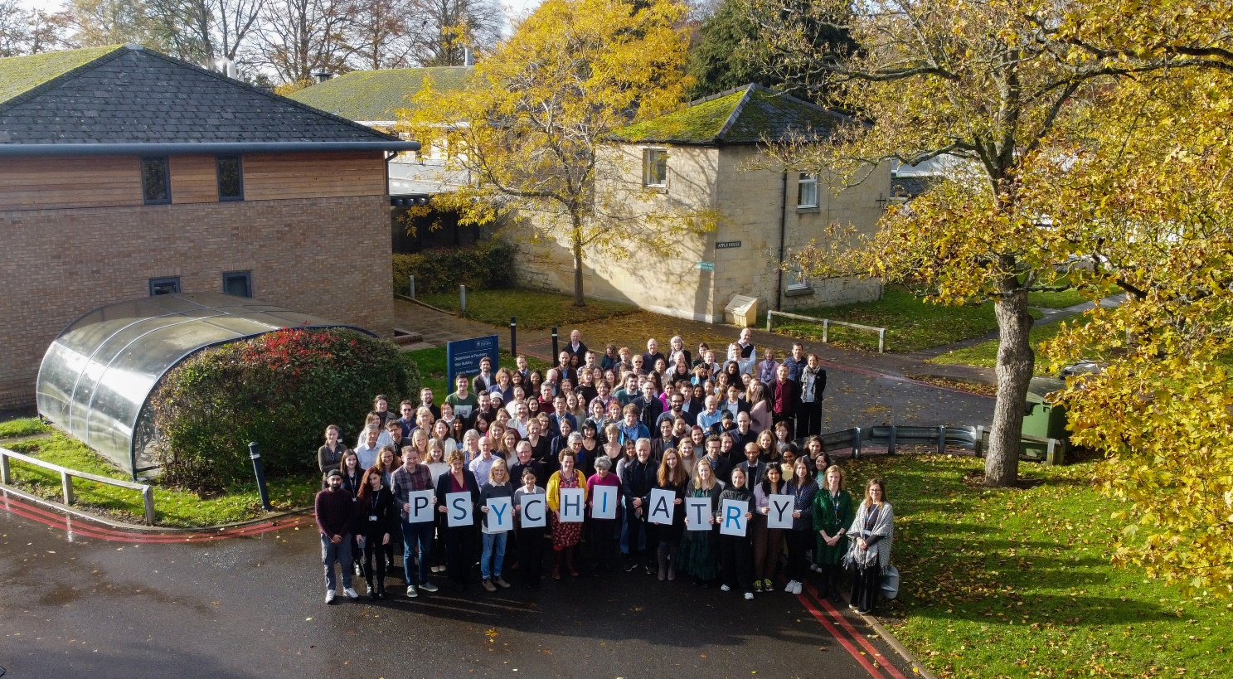 (Photo 1: Photo of the Department of Psychiatry staff taken outside the department)
Our research calibre was recognised in the 2021 Research Excellence Framework (REF) in which we were confirmed as one of the leading centres for Neuroscience in the UK. 69% of our overall REF submission was rated as world leading (4*), and notably this included 100% of our research environment.

(Figure 1: Diagram of how Psychiatry fits into the University of Oxford structure)
Since 2021 the Department has been led by Professor Belinda Lennox (Head of Department, HoD) who is supported by two Associate Heads [AHoDs, Research (M) and People and Culture (F)]. Previously the department was headed by Professor John Geddes from 2011 until 2021, who led the previous Athena swan (AS) submissions. The Department has a devolved and flexible approach to management and decision making, and is organised around research teams, each led by a Principal Investigator (PI). There are currently 41 PIs (20M, 21F) who provide vital support to the HoD in setting research strategy and contributing to the academic functioning of the Department. For the first time in 2023 the proportion of female PIs is >50% (up from 39% in 2020), which represents good progress towards achieving equivalence with the gender split of all research staff in the Department (currently 68%) (Table 1).
Year | Male | Male (%) | Female | Female (%)
2020 | 22 | 61% | 14 | 39%
2021 | 23 | 62% | 14 | 38%
2022 | 24 | 60% | 16 | 40%
2023 | 20 | 49% | 21 | 51%
Table 1: Female PIs in the Department of Psychiatry, 2018-2023

In this application, staff are classified as ‘research staff’ (RS) or ‘professional/support staff’ (PSS). Our RS include clinical and non-clinical academic staff, and our PSS staff include finance, grant and HR administrators; research facilitators; project, trial and facility managers; executive assistants; and technical and IT support staff. When staff data were collected in August 2022, there were 250 staff: 170 research staff (115F, 55M) and 80 PSS (64F, 16M) (Figure 2). The majority of staff are supported by short-term research grants, either through their own personal external funding or as staff employed on these grants. Many staff have joint or honorary contracts with the NHS Oxford Health (OH) Trust. We maintain good collaborative links with our NHS partners, which have been strengthened by the renewal of the NIHR OH Biomedical Research Centre (BRC) in 2022.
The Department provides teaching/training for undergraduate medical students (eight-week course of lectures and tutorials in psychiatry) and graduate clinical and non-clinical students. We currently host a total of 110 postgraduate-taught and -research students which includes: 17 (5M,12F) taught Masters students; 83 (30M,53F) DPhil students; and 10 (2M,8F) MSc by Research students.
Complex clinical department: word count = 186
Figure 2: Headcount of all members of the Department
The amount of medical undergraduate teaching we can undertake is modest, and as a result there are no tenured teaching positions within the Department. The most direct approach for researchers to progress to senior positions in the Department is through successful applications for external funding. We have put considerable effort into developing support for career progression, particularly for people applying for their first fellowships/grants. Thanks to an earlier AS process, the Department has established clear written criteria for the transition to PI status, based on securing substantial research income as an independent leader of a major research programme. (Future Action Plan, FAP, Priority 1).

Growth
The Department has grown substantially over the past decade, from 130 staff and an annual turnover of £9 million in 2010, to 250 staff and an annual turnover of £22.5 million in 2022. Throughout this rapid growth, we are committed to maintaining the supportive environment that is valued by our staff and students. Feedback from our Staff Experience Surveys (SES) suggest that the Department is a positive place to work, and notwithstanding a dip in 2021 (COVID-19), continues to improve across time. In addition, we have seen significant increases compared to 2021 in satisfaction around communication (89%, up 17% from 2021), employee voice (70%, up 11% from 2021), wellbeing and workload (72%, up 8% from 2021 and valued by their manager (85%, up 6% from 2021). In the 2023 survey, across MSD (16 Departments), from a total of 16 themes, Psychiatry came top in 7 (44%), second in 4 (25%), and third/fourth in 3 (19%) (Table 2)

Theme | % | Psychiatry position
Engagement | 82 | 1st
Belief in action | 66 | 2nd
Decision making | 54 | 3rd
Leadership | 84 | 1st
Being managed | 74 | 1st
Employee voice | 70 | 4th
Relationships | 80 | 4th
Communication | 89 | 1st
Pay and benefits | 44 | 2nd
Wellbeing and workload | 74 | 2nd
Career development | 72 | 1st
Induction | 73 | 8th
PDR/CDR | 77 | 1st
Bullying and harassment | 14 | 2nd
Being a manager | 84 | 1st
Mentoring | 29 | 12th
Table 2: SES 2023 results

Review of Governance
Since the last award the senior leadership team and governance structure has substantially changed following the appointment of the new HoD in 2021. The Head of Administration and Finance (HAF) has also changed, with the new HAF coming into post in January 2024 (after a period with an interim HAF). Recognising the need for, and impact of investing in people, and the need to share responsibility, the HoD appointed a new AHoD for People and Culture (, Professor Catherine Harmer, at the end of 2021.

Psychiatry Governance Structure

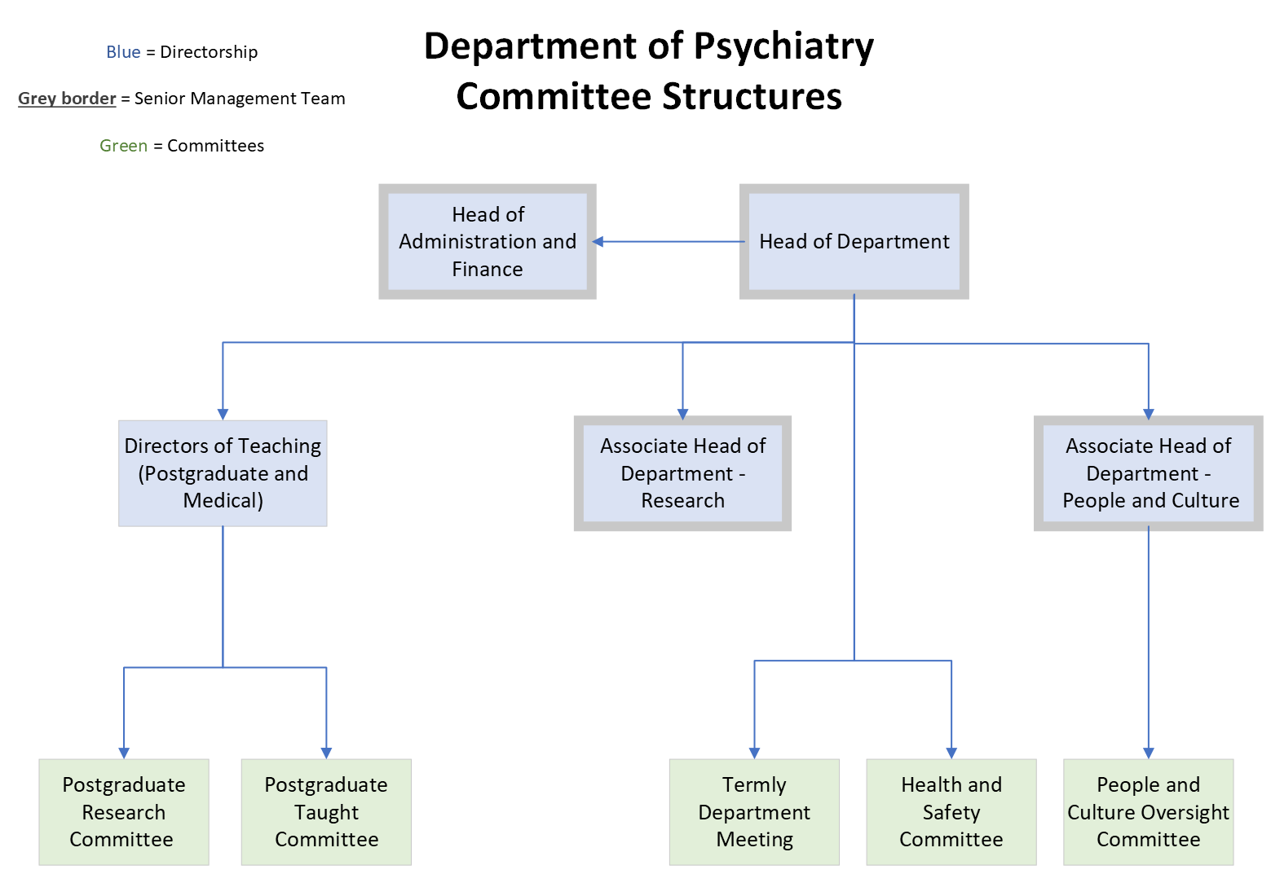
(Figure 3: Depiction of Department committee structure and governance)

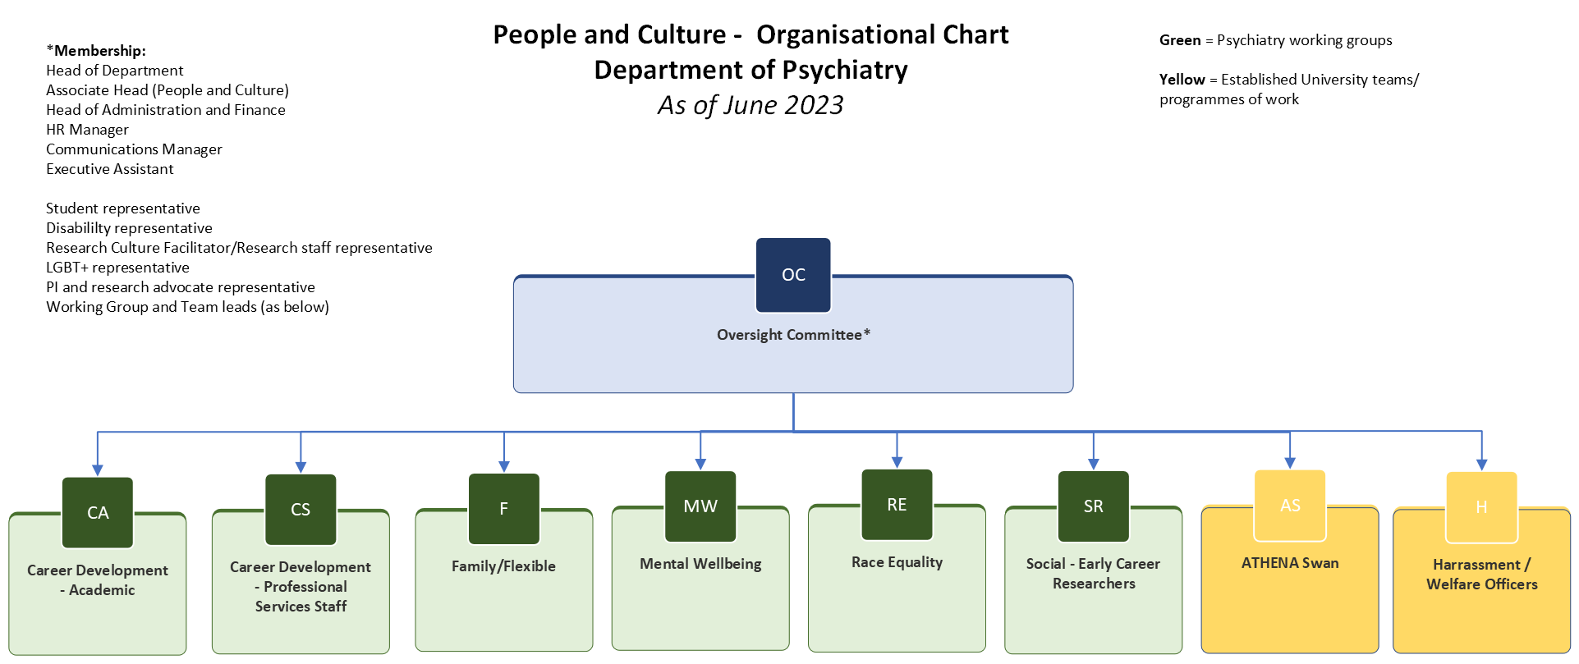
(Figure 4: Formation of the People and Culture Oversight Committee)
Psychiatry reconfigured the way its Equality, Diversity and Inclusion (EDI) work was organised in order to broaden intersectional issues and benefit from a greater level of oversight and action. Accordingly, the Department created a People and Culture Oversight Committee (PCC), chaired by AHoD-PCC and including HoD, HAF, HR as well as a representative from each of six working groups (WGs): race equality, family friendly and flexible working, mental wellbeing, career development (academic and PSS), and the team of welfare officers (Figure 4). We also have representatives for disability, students and Lesbian, Gay, Bisexual and Trans (LGBT+) issues. The AS SAT reports to this oversight committee and also draws on its strength to complete, monitor and update its action plan. The AS action plan (including a wider action plan related to EDI and culture) is held and reviewed monthly by AHoD-PCC (together with HAF, HR and Executive Assistant to HoD) and progress is reported back to the monthly PCC monthly meetings. New actions are incorporated on a continuous basis via the anonymous reporting tool as appropriate allowing staff to submit suggestions or comments on departmental activities.
All staff are expected to contribute to PCC work: it is part of good citizenship and contributes to cross-Department committee experience. Membership and work of the WGs is raised at the whole-department briefing monthly meetings, staff inductions, annual Professional Development Reviews (PDRs) as well throughout online resources (including the Department website, weekly news digest, and termly newsletters). We incorporate presentations from PCC in longer sessions in the Department (for example in the annual staff and student away day) to disseminate our plans and to consult and learn from the wider department, as well as to raise the profile of these groups. Benefits of membership are considered in the annual recognition of distinction exercise, regrading opportunities, merit award scheme and annual staff prizes (including for good citizenship).
The PCC coordinates monthly themes for the department for example highlighting Black history month, LGBT+ history month, and menopause awareness. Monthly themes help us coordinate awareness and training activities and are typically run by members of the working groups, which rotates between groups across the year. Months typically include a weekly newsletter, a team building meeting (e.g. discussion group or coffee morning focused on that theme) as well as a training session or talk.

Current Governance
The Senior Management Team (SMT) supports the HoD in achieving the departments’ strategic objectives and is comprised of the HoD, the HAF and the 2 AHoDs (2M:2F).
The Department has a total of six committees (Figure 3). These cover areas such as strategy and management; graduate studies – both postgraduate research and postgraduate taught; People and Culture (representing the 8 WGs, Figure 4); and health and safety. All PIs are invited to a termly meeting, at which contributions to the strategic planning and management of the department are invited.

3. Athena Swan self-assessment process
Please provide an overview of who was involved in the preparation of this application, how it was prepared, and what plans are in place to support the department’s future gender equality work.

Prior to the self-assessment period
Dr Susannah Murphy was the AS lead from 2017 to 2021 and was responsible for the 2018 action plan generation, maintenance and COVID extension which occurred prior to the current SAT formation. She remains an advisor to the current SAT. This role was supported initially by a dedicated SAT and recently by the PCC. The PAP has been a live document and reflects changes in the AS transformation process as well as activities planned during the COVID period. This plan was reviewed by senior SAT members and individual working groups to develop and implement a relevant and consistent document reflecting the departments diverse activities in both EDI and gender equality.

The 2023 SAT formation
During 2023 a dedicated committee was formed for the AS self-assessment process. Role-based representatives were recruited by advertising for volunteers to increase the range of experiences within the panel and to promote views from across the Department. This includes representatives of the students, PSS, clinical and academics (both early career and senior), with 30% of the SAT being male reflecting the current department structure (Table 3). The SAT are also supported by advisors with experience in key areas: this includes the MSD AS Advisor (Katherine Corr), the previous AS lead and the departmental Communications Manager (CM). The SAT formation was led by Laura Winchester, the AS academic lead with support from AHoD-PCC. The process was supported by the HAF role. Assessment of mandatory data from the department from 2018 -2021 was carried by Moira Westwood (HAF, c.2014 - 2022). Lynn Clee as interim HAF focused on current departmental activity review using her experience of the self-assessment process from other departments. David Hyland (HAF from December 2023) is responsible for the reviewing and committing to actions on the FAP.
Photo | Name and (Gender) | Position in SAT (and job role if different) | Other relevant Departmental or University roles | Work/Life Experience
 | Belinda Lennox (F) | Head of Department (HoD) | Chair of Psychiatry SMT | Four grown up children, worked part time for 10 years, combining clinical and academic training. Has a weakness for rescue animals (currently dogs, cats and chickens)
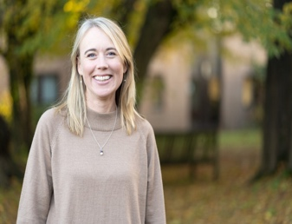 | Catherine Harmer (F) | Associate Head of Department - People and Culture  (AHoD-PCC) | Member of Psychiatry SMT  Harassment Advisor, HA (2016-2022) | Three school aged children including twins. Currently completing the Inclusive Leadership Course in Oxford. One of the first cohort of female Professors in the department. Loves dancing (badly) and yoga (even more badly).
 | Lynn Clee (F) | Interim Head of Administration and Finance (interim HAF) | Member of Psychiatry SMT | Interim HAF August-December 23, covering the period between the previous HAF leaving and David starting. She has one grown up son and joint caring responsibility for an elderly parent. Loves dog walking and sport.
 | David Hyland (M) | Head of Administration and Finance (HAF) | Member of Psychiatry SMT | Four children (three grown up, one doing A-levels). Plays the piano.
 | Philly White (F) | Departmental HR Manager (HRM) | Supports staff through  key transitions/  parental leave | Two children. Works part-time  around school  terms.
 | Laura Winchester (F) | AS Academic Lead  (Postdoctoral Researcher) | Co-lead of Psychiatry Family Friend and Part-Time WG | Parent of two primary school age children and fair weather runner.
 | Katherine Shepherd (F) | Communications and Administrative support  (Executive Assistant) | Secretary to Psychiatry PCC, Administrative support to AHoD People and Culture  Member of PSS Career Development WG | Interested in workplace wellbeing. Keen road runner and dog enthusiast.
 | Isabelle Butcher (F) | Representative of Postdoctoral Research Assistants  (Postdoctoral Researcher) | Member of Mental Wellbeing WG
 | Thomas Reilly (M) | Graduate Student Representative  (DPhil student) | Student representative for Psychiatry  Member of Mental Wellbeing WG  Member of Family Friendly and Part-Time WG | Has school-age child and a baby. Will be taking advantage of shared parental leave.
 | Clare Mackay (F) | Representative of Non-clinical Academics in Department  (Professor) | Member of Psychiatry Family Friendly and Part-Time WG | Parent of a teenager and work 0.9FTE (9-day fortnight). Inclusive Leadership Course graduate. Keen oil painter and campervan lover.
 | Rebecca Park (F) | Representative of Clinical Academics in Department  (Associate Professor, AP)
 | Jennifer Potts (F) | Representative for Support Staff  (Project and Trial Manager) |  | Part-time worker with two children under the age of five.
 | Phil Burnet (M) | Representative for Education and training  (Associate Professor, AP) | Director of Graduate Studies (DGS)  Chair of MSc Committees.  Principal Investigator | Four grown up children. DGS for 10 years, led the conception and development of our taught MSc course. Enjoys cooking and metalwork. Qualified acupuncturist.
 | Erdem Pulcu (M) | Data advisor and analyst  (Postdoctoral researcher) | Lead Harassment Advisor | Married with no children. Likes number crunching, gaming and classic cars. Owner of a greyhound.

(Table 3: The Self Assessment Team)

The Self Assessment Process
The SAT was formed during the reporting period to drive forward the development and improvement of practical steps towards the advancement of gender equality. The SAT ensure that the principles of AS are embedded throughout the culture of the Department and contribute to the PCC, whose focus is on broader inequalities and EDI issues. They met monthly for six months prior to discuss activities and completion of the original action plan before beginning the planning process for the next period. The SAT reports to the SMT via the AS Academic Lead with support and review from the PCC, and as described above, the senior leadership team are fully involved in, and committed to, the self-assessment process.
The SAT made a commitment to maintain a balanced workload among members. One member (Communications and Administrative Support) tracks and distributes tasks between SAT members, and all tasks are reported in SAT minutes and reviewed. Focused satellite groups responsible for co-ordinating data collection, writing, and survey response were created to lead on aspects of application completion. Communication of activities occurs via weekly newsletters and during the HoD monthly meeting.
The data analysis satellite group has performed a comprehensive self-evaluation annually. They collated data from multiple sources, including staff surveys, core staff statistics, and information on student recruitment, achievement, and satisfaction. One of the key sources of data is the biannual staff survey which is administered by MSD (Appendix Figures 1-14). Departments have the option to submit questions relevant to their own processes. Surveys carried out during this reporting period were in 2021 and 2023 allowing detailed assessment and consultation of staff post-COVID and pre-assessment period. The SES has been analysed and discussed in the monthly SAT. 77% of the invited staff completed the staff survey in 2023 (26%M:71%F, 35%PPS:65%AS).
The SAT review process initially focused on the 2018 Previous Action Plan (PAP). Areas flagged by the departmental SES were discussed by the full SAT to decide on progress and rate activities. The plan was then split for individual members to gather data, review and rate each action and/or success measure as Red, Amber or Green (RAG). These activities and data review formed the basis of discussion for development of the FAP which was defined in the SAT before being shared with PCC WGs to provide relevant actions and tasks within their own specialist subgroups.

Moving forward – SAT in the wider department
After renewal the SAT will meet bi-annually for reassessment of the AS dedicated FAP. This will allow us to realign with wider department EDI and flag key initiatives for gender equality. Success and progress on actions will be monitored by annual staff departmental data collection, biannual divisional staff survey and direct feedback from specific subgroups allowing the SAT to reflect on recent changes and RAG rate relevant activity and focus on priority areas. Monthly activities will be supported from within the PCC and focused WGs including the family friendly and part time WG. PCC working groups responsible for supporting actions meet bimonthly to discuss and plan relevant activities.

Section 2: An evaluation of the department’s progress and issues
In Section 2, applicants should evidence how they meet Criteria B and D:
- Progress against the applicant’s previously identified priorities has been demonstrated
- Evidence-based recognition has been demonstrated of the key issues facing the applicant
Recommended word count: 3000 words
- Evaluating progress against the previous action plan (PAP)
Please provide a critical evaluation of your most recent action plan and any other actions you have initiated since your award.
In the 2018 PAP we had 38 objectives, 77 action points and 90 associated success measures (SM). Despite the challenges of the COVID-19 pandemic, we fully met 74 (82%). Significant progress was made towards another 13 Amber actions (14%), leaving 3 red actions (4%) which were not completed.

Response to 2018 application feedback
In addition to our objectives, the feedback from the AS committee to our Silver award requested additional information relating to support for part-time (PT) students and for PT working patterns to be more substantially recognised. In response, we increased support for PT students. This is reflected in Green rated PAP Actions 2.4 and 2.5, and the 12% increase in PT DPhil students from 2018 to 2023. The restructuring of the WG activities reflects the Department’s commitment to equality initiatives, which will be developed further in our Future Action Plan (FAP).
HoD’s lobbying has ensured working patterns are taken into account by the University Recognition of Distinction (RoD) panel for award of associate and full professorships (PAP Action 3.4), working patterns are now included in the application form. The HoD refers to working patterns in all RoD letters of recommendation for those working less than full-time.

Methodology of Previous Action Plan Implementation
Responsibility for actions was assigned in the PAP, including through the set-up of WGs which report into the PCC. Where appropriate, WGs were given access to departmental resources including internal budget. Several objectives were actioned by devoting ‘theme months’, which raised awareness, training opportunities, and often included inviting external speakers/experts for teaching and seminars.
Progress against actions was evaluated via periodic self-assessments of the PAP to review status of each action (in 2020, 2021 and 2023 in PAP). Data was collected from events, University databases, feedback from Department members (qualitative and quantitative) and the bi-annual SES. Staff and students answered an online survey implemented by an independent provider to assess changes in culture, policy awareness, etc. Each action point was assessed based on completion of the SM outcome. With the support of the SAT we have detailed actions and activities requiring adjusted approaches for success.

The impact of COVID
COVID had a substantial effect on many aspects of the lives of everyone in the Department, and it is widely recognised that the impacts disproportionately impacted women, particularly those with younger children. The impact can clearly be seen in the SES results, for example with rates of satisfaction, reducing in 2021 before beginning to rise again in 2023 (Appendix Figure 21). This shifting baseline from the SES comparison has impacted predicted success measures (SM) in the 2023 results.
Throughout the pandemic many (but not all) staff worked from home and we have faced the same challenges as the rest of the country in adapting to remote working - providing equipment loans, new approaches to flexible hours and end of contract redeployments. HoD briefings moved online and from monthly to weekly, and staff were supported with regular email communication, online social events, weekly news digest and a webpage sign-posting to internal and external sources of support.
The pandemic affected many items of the PAP and particularly those that required in-person. We set ambitious targets for some of our engagement activities (e.g. >90%) that were estimated based on baselines from previous years, and were then not met because of the changed circumstances. Where appropriate these impacts have been noted in the relevant sections below.
In 2021, the University introduced ‘New Ways of Working’, a framework building on lessons learned during the pandemic to support staff in finding flexible working patterns that work for them and their departments. Within the Department, in addition to signposting support and information, we held a seminar and panel session “Adapting working patterns post-Covid and beyond” with open questions to senior staff members to discuss issues and best working practices. These approaches to flexible working and PT schedules have formed the basis to some of continued adaptions to the new way of working (PAP Action 1.22, FAP Action 5.11)
Word count (COVID) = 311

Reflections on Green Actions
Despite the impact of COVID, the Department made strong positive changes to implement objectives and complete SMs on the PAP. We have grouped these by facilitators to provide a brief narrative of key successful actions.

FACILITATOR #1: Moving to a more inclusive EDI approach
The development of the new PCC (PAP Actions 1.1–1.4) enabled us to diversify our approach to action implementation across the Department. The structure and change in emphasis of committees promoted activity across the Department with wide ranging effects including improvements to wellbeing and focused activity on intersectional groups. The externally run focus group on racial inequalities highlighted changes needed for the next phase of the action plan.

FACILITATOR #2: Engaged and active leadership team
Objective progress has been actively supported by senior leaders in the Department. The following actions demonstrate how engaged and active leadership can model good practice and show how culture is foregrounded in all spaces.
In career progression an increase in female promotion and the recruitment of two female chairs (PAP 3.1-3.5) shows the commitment to positive action. This is also clear in the successful implementation of gender balanced recruitment panels (PAP 4.1).
For staff with caring responsibilities, by raising awareness of options, 7 staff have taken Shared Parental Leave (SPL) from 2020 to 2022 (PAP 5.3). This staff group were also supported by the introduction of the “The Science of the Mind” fellowship departmental scheme whereby priority was given to candidates whose career progression has been delayed due to personal circumstances including caring responsibilities or health conditions.
Monthly PI peer-to-peer meetings were introduced from June 2023. These are well attended (Appendix Table 46) and provide a forum for sharing best practice of management and disseminating training information to PIs. Monthly topics can implement key AS strategies and will be vital going forward. These positive leadership models will be key in the introduction of the “emerging leaders pathway” scheme (FAP 1.1-1.17) as well as driving forward activities to tackling systemic inequalities (FAP Priority 5).
FACILITATOR #3: FLEXIBLE PRACTICES INTRODUCED DURING COVID
Remote seminar attendance promotes flexible working for many groups including clinical academics (PAP 3.10), carers and those impacted by accessibility. After feedback from staff via WGs this practice is continued throughout the Department whereby the monthly HoD meetings and research meetings are streamed online and recorded for later viewing.
The furlough scheme was used 21 times but only once by a male. To gain feedback from these staff (PAP 5.4) we ran a focus group with affected staff to discuss their thoughts on the scheme and how it could be improved. The focus group generated a reference report and a similar model will be used to understand the needs of part-time staff in the FAP (Action 5.10).
Word count (COVID) = 124

FACILITATOR #4: Communications
Weekly departmental newsletters and reinvigoration of the HoD monthly meetings has increased staff awareness of PCC activities (Appendix Figure 11). Theme months carried out by the PCC and focused on specific EDI areas have allowed us to successfully complete outstanding actions (PAP 6.14-16). Wednesday Research Meetings have allowed us to support researchers career development (PAP 4.14,4.16) as well as implement training sessions and relevant knowledge transfer (PAP 6.5-6.6). These strategies will be used to improve engagement in our intersectional groups (FAP, Priority 2).

Reflections on Red and Amber Actions
The majority of our Amber and Red actions can be accounted for by one of three barriers: 1) monitoring systems that were not available, 2) ambitious targets that were hampered by the pandemic and 3) in progress but not yet complete.

BARRIER #1: Monitoring systems

AMBER: PAP Actions 4.2- 4.3, 4.5, 4.8: Focused Training and Monitoring uptake
Rates of bullying and harassment (B&H) training are improving overall from 2019, but work is needed to achieve the target of 100% uptake (Appendix Table 47). Barriers to implementing monitoring of training are due to difficulties with the University online training site used for reporting. The ‘CoSy’ system does not allow easy HR access or readable outputs to see when/who completed training. Therefore, monitoring of training took significant resource.

The University introduced a self-service reporting tool in January 2024 which brings together all training providers and enables reports on who has not completed training, allowing reminders to be sent. We hope that this will be the development we need to ensure full compliance. Additional staff have been recruited to the HR team to allow monitoring and follow-ups, as well as other EDI tasks. These tools will be used in the tracking and pilot implementation of the “emerging leaders” training and B&H training (FAP 1.10-1.14, 4.4-4.5).

AMBER: Action 6.2-6.3 Improve the provision and uptake of management training
We require new managers to complete management training but take-up has been low (7 in total in the last 3 years) and follow up/monitoring has not been possible. We ask new managers to do a mandatory management course via the induction e-mail, now replaced with the People and Organisational Development (POD) course “The Confident Manager”. In the 2018 SES results, 30% of managers reported they were not confident applying HR policies, which increased to 62% in 2023. This is a big increase but not to the SM of 100%. With the improvement of training accessibility and tracking, we hope to be able to continue this improvement in the FAP.

BARRIER #2: Did not achieve success target (covid-19 baseline shift)

AMBER: Action 4.4 - Create webpages on Department website with information from induction pack and staff handbook
Following the launch of the induction webpage, success was measured by comparing percentage satisfaction ratings (90% on induction useful, 80% on clarity of career development resources). The impact does not pass predicted SMs (90% vs 84% for induction, 80% vs 66% on career development opportunities), albeit it is still an improvement compared to 2021 (+9% and +8% respectively). A challenge to successful implementation is the uncertainty whether 2023 staff survey responses truly reflect opinion on Department induction (as opposed to University induction). Indeed, there is a challenge that signposting and resources are across many different systems. Evaluation outside of SES may be required to gain clearer feedback on the induction process. Group-focused staff handbooks are being introduced (FAP 1.18-1.20) which will allow resources tailored to individual group needs.

AMBER Action 4.14: Impact of Department Research meetings on Grant Successes
60% of staff felt the departmental research meetings were a good way to access feedback on grant proposals. Upon internal review we discerned that research meetings are often used by ECRs and less experienced staff members for feedback and grant development who often require more support but are not necessarily among the most successful applicants. This therefore reflects an overestimate in SM rather than a barrier for the action. The AHoD-R has been successful in our department and our resources are now shared across MSD.

AMBER Action 4.17, 4.18: Promote professional and support staff career opportunities.
Only 82% of 81 PSS staff completed the 2023 SES (SM>90%). Of those, 69% consider themselves supported to think about professional development and 61% said they are actively encouraged to take up career development opportunities; this is lower than the Department average. However, it is a 12% increase over 2021 ratings highlighting the difficulty for career development related questions during this time associated with COVID-19.
Word count (COVID) = 66
A PSS Career Development WG was re-established in 2023 to help address issues affecting this staff group. All members of PSS (whether core administration, research support or project management) were invited to join a mailing list to keep up-to-date with local, divisional and University-wide opportunities to enhance their role and future career.

AMBER Action 6.12 & 6.13: Offer media training to all staff and increase male involvement in outreach
Our previous application highlighted that more women (69%) than men (42%) were involved in outreach. In the latest PDR round, there was a more equal engagement in outreach reported (41%F, 36%M) although this did not reach the proposed SM (>70%).
There was also previously a gender imbalance in the types of outreach that people were engaged with, with women undertaking more science festivals and school engagement, whereas men were doing more media and public talks. Consultations with senior staff highlighted that women often turned down media invitations because they did not feel equipped for high profile media work. We provided a successful media training course, which was positively received. However, women in public life are more likely than men to be subject to an adverse public response, and the relative lack of psychological safety needs to be acknowledged. Therefore, this rating reflects our adaption of actions around visibility of women to foreground safety over meeting arbitrary targets.

AMBER: Action 6.14 Establish social committee to organise annual programme of Department-wide social events
The target of 90% of people feeling included in social events was not met (68%). We have a number of groups who organise social activities, including the Early Career Researcher (ECR), social and wellbeing WGs. We have a varied and vibrant array of social activities which are designed to appeal to staff with a range of different interests. During the pandemic, there was a decrease in the proportion of staff who felt included in the department’s social and networking activities, which has nearly recovered to pre-pandemic levels, although there remains a need to increase inclusion (Appendix Figure 16), particularly for women. Positive improvements are continued in the FAP targeting activities to include intersectional groups.

AMBER and RED: Action 1.7-1.8: Increased awareness of the AS process
Staff awareness of AS is high (78%) but does not meet the target SM (90%). We have recently held AS theme months and discussion of survey responses in HoD meetings. However, the Department’s move to the more inclusive EDI strategy incorporating AS means the SM is no longer solely relevant. In fact, if measuring commitment and knowledge of EDI activities, the survey shows 87% of staff agreeing that the Department is committed to promoting EDI (9% higher than division and 11% higher than University) and high levels of trust that they will be listened to in belief in action.
We need to address issues with student survey response rate (36% in 2023) meaning it is difficult to gauge awareness of the EDI and AS within the student body. Student representatives are present on both the SAT and PCC WGs, and this will be an activity for the FAP.

BARRIER #3: Time and resource pressures / in progress but not complete

AMBER: 5.1 Repeat parental leave survey
The parental leave survey was circulated in September 2020 to staff members on leave or who had taken leave within the past five years. The response rate was 55% (n=11). Half of respondents had read the parental leave guide before completing the survey and 77.8% had read the parental leave checklist. The parental leave survey will be repeated (FAP 5.15).

AMBER: Action 2.6 Increase teaching opportunities for postgraduate students
Although opportunities to teach are advertised to all students, we were not able to achieve our SM of increasing to >50% of eligible students involved in teaching by 2021. This is likely due to time constraints and practical barriers, for example students are not able to teach until second year of studies. It would be helpful to have first year opportunities to teach, particularly as other MSc/DPhil programs follow this style.

AMBER: Actions 3.6-3.7 Increase the support given to ACFs
Support of clinical staff in the Department has proved difficult during the review period due to lack of time from current clinical staff and ongoing data assessment. Academic Clinical Fellow (ACF) briefing documents require updating and recirculating to supervisors. Support activities are to be reviewed and revised in the FAP, where Priority 3 includes actions for a clinical representative to be recruited to the PCC in 2024. We also plan to recruit 2 clinical staff (in addition to HoD and clinical lead) to Department WGs by 2026 which will be key in ensuring clinical voices are represented (FAP 3.10).
(words clinical: 99)

2018 – 2023 Action Plan

Theme 1: Improving the structure of the Self-Assessment Team and Working Groups, and increasing staff/student involvement in equality initiatives
Objective | Actions 2018-2023 | Specific tasks, person responsible, and timescale | Justification | Success measures | 2020 review | 2021 review | 2023  Review
Further develop the structure of the AS Working Groups (WG) | 1.1  Appoint a chair of each WG  1.2  Ask all PIs to identify at least one member of their research team to join an AS WG  1.3  Ensure that the WGs are gender balanced and have representatives from students, research staff and PSS  1.4  Ask each WG to report to the SAT on a biannual basis | AS Lead to appoint a chair of each WG (Summer 2018)  AS Lead to ensure WGs are gender balanced with representatives from students, Researchers and PSS (Winter 2018)  HoD (SAT) to ask PIs to identify at least one member of their research team to join an AS WG (Autumn 2018)  AS Lead to ask each WG Chair to report to the SAT (biannually 2018-2023)  AS Lead to review WG membership (annually from Sept 2018) | NEW ACTIVITY: Formation of AS WGs to increase staff involvement in AS process and more fairly share the AS workload.  NEED: WGs will be an important method of involving more staff in AS activities and implementing our action plan. The structure and leadership of these WGs is critical to the success of this model. | Gender of WGs and chairs is proportionate to the Department (70% F)  All WGs have representatives from students, research staff and PSS  All research groups have representation on a WG | Amber  Amber  Green | Amber  Amber  Green | Green  Membership in line with department (71%F), Chairs (100% F)  Green  FFPT WG has members from all staff groups  Green  All 3 core groups represented on SAT and reporting working groups  Green  All working groups report to the PCC, AS specific WG (FFPT) report to both forums.
Increase staff/student awareness of, and involvement in, the AS process | 1.5  Share SAT minutes on internal network drive  1.6  Include an annual article in the Department newsletter highlighting AS activities (e.g. “You said, we did”)  1.7  Include questions about awareness of and involvement in AS in staff and student surveys  1.8  Repeat staff survey biennially and maintain high response rates  1.9  Hold staff survey briefings to share feedback and actions to be taken | DA (SAT) to upload SAT minutes to network drive (monthly, 2018-2023) and inform all staff they can access them (annually, 2018 – 2023)  CM (SAT) to write annual article on AS activities in consultation with SAT (annually from Oct 2018)  AS Lead to include AS related questions in 2020 and 2022 staff surveys  Postgraduate Student WG to include AS related questions in 2019 and 2021 surveys  AS Lead and CO (SAT) to circulate and promote staff surveys using successful methods from 2018 (e.g. distribution software with built-in reminders, posters in Department kitchens) (2021, 2023)  AS Lead to organise staff survey feedback sessions following staff survey (April 2020 and 2022) | AIM ACHIEVED: We repeated our whole staff survey in 2016 and 2018 and increased response rate considerably (42% in 2016; 90% in 2018).  NEW ACTIVITY: Staff survey feedback session held in 2018 to highlight the ways in which the staff survey is used to shape the AS agenda going forward. Staff survey report circulated to all staff and posted on website.  NEED: We do not currently monitor staff awareness of or inclusion in AS activities. Our PSS workshop suggested that staff appreciate being consulted and would like to be more involved. Survey briefings help staff feel that their feedback is valued and provide an incentive for responding in the future. | >90% of staff are aware of AS activities in 2022 staff survey  >90% of students are aware of AS activities in 2021 student survey  >60% of staff feel involved in AS activities in 2022 staff survey  >60% of students feel involved in AS activities in 2021 student survey  >90% response rate on 2020 and 2022 staff survey  Staff survey feedback sessions held in 2020 and 2022 with good turnout (>40 people) | Red (covid) | Amber | Amber  In 2023 survey 78% of staff were aware of the people and culture initiatives.  Red  Student survey had 36% response rate  Amber  Staff survey in 2023 had 78% response  Green  Staff survey response section held in monthly HoD meetings
Ensure fair workload allocation in SAT | 1.10  Rotate minute taking in SAT meetings  1.11  Review SAT workload annually, including gender balance  1.12  Repeat poll of SAT biennially | AS Lead to assign minutes to SAT members when meeting dates are circulated (annually)  AS Lead and SAT to annually review SAT membership and workload (Sept 2018-2022)  MSD AS Facilitator to conduct anonymous poll of SAT (Feb 2020 and 2022) | NEED: In a recent poll of the SAT, 90% of members were happy with how it is organised. However, members identified the need for more collective responsibility, increased male involvement and fair sharing of the workload. The introduction of the WG structure means that each SAT member has specific areas of responsibility. However, it is important to monitor SAT involvement and workload and make necessary changes to SAT membership regularly. | 100% satisfaction with how SAT is organised in 2020 and 2022 SAT poll  >80% of SAT reporting that the SAT workload allocation is fair in 2020 and 2022 SAT poll | Green |  | Green  Role in SAT to ensure actions and workload distributed

Theme 2: Continuing to support our graduate students
Objective | Actions 2018-2023 | Task, person responsible and timescale | Justification | Success measure | 2020 review | 2021 review | 2023 update
Further understand the reasons why graduate students do not accept offered places | Routinely record reasons for not accepting DPhil and MSc(Res) places  Routinely keep records of application numbers, offers made and gender balance | Deputy DGS (SAT) to collect reasons for not accepting offered places (Jan-July 2019, 2020, 2021)  Postgrad WG to review reasons with focus on gender differences (July 2019, 2020, 2021)  SAT and Postgrad WG to develop interventions to encourage men to accept graduate places (Aug-Sep 2020) | NEED: Over the last few years, we have had a higher application to offer rate, but lower offer to acceptance rates in women. An offer of a place is dependent on funding being secured and lack of funding is the main reason given informally for not accepting a place, although we do not routinely collect these data. Going forward, we will formally record reasons for not accepting a place to better understand and address any gender differences | Equal offer to acceptance rate for male and female DPhil/MSc(Res) by 2021 | Green | Amber (covid) | Green  In 2023-2024 36 female and 9 male places were offered with only 6 withdrawals.
Collate and disseminate information about funding opportunities from internal and external source | Annually collect information on internal and external funding resources as part of a postgraduate scholarship and award survey | Postgrad WG to ask students to complete the postgraduate scholarship and award survey once per year (March 2021, 2022, 2023) and to collate a funding list.  Deputy DGS (SAT) to circulate the funding list to continuing students and incoming students (Mar- Sep 2021, 2022, 2023) | NEED: Over the last few years, lack of funding was the main reason given for not accepting a place. Going forward, we will collate a list of internal and external funding sources and thereby help potential students to identify other less known funding sources, they could apply for. | An up to date and accessible list of internal and external funding sources made available to current and prospective graduate students |  |  | Green  Students are aware of possible funding opportunities and avenues through emails.
Ensure part-time study is accessible and positive | Advertise the possibility of part-time graduate study and include profiles of PT students on website to encourage uptake  Review the satisfaction of part-time students in our biennial student survey and termly student barometer | Deputy DGS (SAT) to ensure all adverts for graduate study include information about part-time study (ongoing 2018-2023)  CM (SAT) to include profiles of PT students on graduate study webpages (Dec 2018)  Postgraduate Student WG to analyse responses on student survey and student barometer for part-time students separately to identify any issues specific to this group  Postgrad WG and SAT to develop targeted initiatives if necessary | ACTION ACHIEVED: Change in University regulations to permit part-time DPhil/MSc(Res) study from October 2018.  IMPACT: We have already obtained approval to accept three students to study part-time.  NEED: Now the regulations have been changed, it is important to make sure that applicants are aware of the possibility of part-time study and that the experience of part-time students is as positive as that of full-time students. | All graduate studies adverts include PT study statement  6 part-time graduate students enrolled by Oct 2020  No difference between PT and FT student satisfaction in student surveys |  |  | Green  Students are aware that they can complete their studies PT and or full time.  Green  6 students enrolled to study PT for MSc(res) and DPhil  Green  PT students did not raise issues with PT study in 2023 survey
Increase teaching opportunities for postgraduate students | Provide teaching opportunities for postgraduate students on the new MSc in Clinical and Therapeutic Neuroscience  Collect information on the reasons why students want to teach and the barriers to teaching, as part of the postgraduate survey | Postgraduate Student WG to liaise with DGS to ensure that opportunities for teaching on the new MSc course are created and advertised to students (course due to be launched in 2019) | NEED: Our 2017 postgraduate survey highlighted that students would like more opportunity to gain teaching experience during their graduate studies. Only 35% of our students are currently involved in teaching. Providing more teaching opportunities is challenging given how little teaching is delivered in the Department. However, in 2019, we will be launching a new MSc course, which provides an opportunity to increase teaching for our students. | >50% of eligible students involved in teaching by 2021 | Amber (covid) | Amber  Green | Amber  Opportunities to teach are advertised to all students through email and other forms of communication but uptake not >50%.  Green  Student survey implemented within department.
Provide more statistics support for graduate students | Organise annual one-week statistics workshop for postgraduate students and postdocs  Offer additional statistical support to students | Deputy DGS (SAT) and DGS to organise statistics workshop and invite all students and postdocs (March, 2019 – 2022)  Postgrad WG to monitor effectiveness through PG survey (2019 and 2021) | NEED: Our 2017 postgraduate survey highlighted that our graduate students need for more statistics support. Our DGS is working to increase support and plans to implement an annual one-week statistics workshop. | Statistics workshops held annually  50% of students attend workshop  90% of attendees find the workshop useful |  |  | Green Workshops run annually and available part-time.  Green  Strong positive feedback available from all students surveyed
Increase networking opportunities for students | Organise student meetings/presentations with other departments  Develop an alumni page of students | Deputy DGS (SAT) and Postgrad WG to set-up interdepartmental student meetings (2021, 2022, 2023)  Postgrad WG to monitor effectiveness through PG survey (2022, 2023)  Deputy DGS (SAT) to add alumni student profiles to the departmental website (ongoing) | NEED: In the PG survey, students expressed an interest to present their own work and to learn about the work of other students in related departments.  To increase networking and presenting skills we are planning open Zoom meetings for students within Psychiatry, Experimental Psychology and NDCN in the first instance.  Furthermore, to increase further networking opportunities with former students in the Department, and to see their career paths, we will add alumni student profiles to the departmental website | Interdepartmental student meetings held at least once per year.  Alumni student profiles on the departmental website | Amber  Amber | Green  Amber | Green  Students invited to present work annually at Neurosciences meeting and joint Neurology / Psychiatry conference days.  Green  Students awarded prizes for essays and dissertation profiled in staff newsletter and website

Theme 3: Improve gender representation across the academic career pipeline
Objective | Actions for 2018-2023 | Specific tasks, person responsible and timescale | Justification | Success measure | 2020 review | 2021 review | 2023 update
Increase number of women with URL, AP and Professor titles | Identify all eligible candidates for RoD schemes annually and encourage applications  Provide internal support for RoD applicants to strengthen applications  Offer mentorship for unsuccessful RoD candidates  Request PT working patterns are taken into account in the assessment of research outputs of PT researchers for the RoD | DA (SAT) and HoD (SAT) to identify and email eligible candidates, encourage them to apply and invite to meet and discuss. (March 2018 - 2022)  DA (SAT) and HoD (SAT) to establish gender-balanced internal RoD committee to review applications prior to submission and provide advice to strengthen applications (April 2018 - 2022)  HoD (SAT) to ensure all unsuccessful candidates are offered mentorship by a senior member of the Department to support them to meet the requirements (September 2018 – 2022)  HoD (SAT) to request working pattern is taken into account by the University panel in supporting letter (May 2018-2022) | AIM ACHIEVED: We have increased the number of women holding Associate Professor and Professor titles since 2014.  NEED: The proportion of women holding the Professor title is not consistent with our pipeline. We currently have no staff with the URL title. | 3 successful female applications for Professor title by 2022  3 successful female applications for AP title by 2022  2 successful female applications for URL title by 2022 | Green | Green | Green  3 new female professors appointed  Green  9 new female associate professors  URL applications suspended in 2021, the only URL in Psychiatry converted to AP in 2022  Green  Feedback and mentorship is offered to all unsuccessful RoD candidates  Green  The HoD includes statements on PT working patterns in her letters of recommendation to the central RoD committee
Increase number of women holding statutory chairs | Ensure gender balance in applications for two vacant statutory chair positions | HoD (SAT) to brief search committee/head-hunters that we have a target of 50% female applications  HoD (SAT) to advise Chair of search committee of the necessity to follow University procedures, requiring permission from the Vice Chancellor to proceed at each stage of recruitment if no women are being taken forward | NEED: Senior positions in the Department rarely become vacant. We currently have two vacant statutory chairs (one clinical, one non-clinical). This is an important opportunity to increase representation of senior women in our Department. We will work hard to identify potential female candidates for these positions. | One new female statutory chair to be appointed by 2020 | Amber | Amber | Green  Two females have been appointed to the vacant statutory chairs, in 2022 and 2024.
Increase the number of Academic Clinical Fellows who go on to further academic work | Develop trainee webpages on Department website to increase profile of ACFs and attract high quality applicants  Increase the support and monitoring given to ACFs  Produce briefing notes for ACF supervisors | Director of Medical Studies (SAT) and Clinical Academic WG to produce trainee pages on Department website to increase the visibility of ACFs in the Department for prospective applicants (June-Dec 2018)  Director of Medical Studies (SAT) to have individual meetings with ACFs at the start of their placement and annually to set expectations and monitor progress (ongoing)  Director of Medical Studies (SAT) to produce a briefing document for all ACF supervisors to clarify expectations and encourage proactive involvement of ACFs in publications (Sept 2018) | AIM ACHIEVED: We have established Academic Clinical Fellowships, NHS-funded positions that provide protected academic time for trainees.  IMPACT: Since 2014, 10 ACFs (6M, 4F) have been appointed.  NEED: Although ACFs are an important route into the academic clinician career pathway only 20% of our ACFs have gone on to further academic work since 2014. | Trainee pages of website launched in 2019  Briefing documents circulated to all ACF supervisors between 2018-2022  Increase in publications authored by ACFs  40% of ACFs to go on to further academic work (e.g. PhD) by 2020 |  |  | Green  Website active  Amber  ACF briefing documents prepared but supervisor response needs monitoring  Green  We have funded 3 local ACFs with the deanery to increase the available “pool”. Since 2020, one male and one female have gone on to further academic work
Support female clinicians to continue with academic work | Host biannual female academic networking events  Provide online access to podcasts of Department seminars to clinicians  Proactively promote opportunity to apply for honorary clinical positions within the Department to clinical teams  Continue to work to develop joint Oxford Health NHS Trust/University posts through the BRC | Clinical Academic WG to host biannual female academic networking events (biannually 2018-2022)  CM (SAT) to upload podcasts of Department seminars to website (ongoing)  Director of Medical Studies (SAT) to give talks to local clinical teams to inform them of the opportunity (and criteria) to apply for honorary departmental positions (2018 and 2019)  HoD (SAT) to continue to discuss joint Trust/University posts with Oxford Health (ongoing) | NEW ACTIVITY: We have formed a Clinical Academic WG who have actively consulted with 22 current and former female clinicians about the challenges of clinical academia.  NEED: Consistent with the national picture, we have an under-representation of women clinical academics. We are keen to support the female clinicians who have already worked in the Department. Many of these women have returned to clinical work but are keen to maintain links with the Department. They reported appreciating the opportunity to network with other female clinicians. They also requested access to online podcasts of seminars that they are unable to attend due to clinical commitments. We have recently formalised the process for applying for an honorary post within the Department and will promote this to local clinical teams. For a small Department like ours, it is very difficult to create new posts, but we will continue to explore possibilities with Oxford Health NHS Trust for joint Trust/University posts. | Networking events held biannually and attended by >10 female clinical academics  Online seminar podcasts accessed by at least 3 people per podcast  Increase in number of female Honorary Clinical Senior Lecturers (HCSLs) and other honorary positions by 2022  New joint Trust/University post established by 2021 | Green | Amber (covid) | Green  Whole Department networking events 3 per year, plus women in neuroscience events 2/year  Green  seminar series available online since 2019  Green  12 (44%) female Honorary Clinical Senior Lecturers (HCSLs)  Green  4 new joint Trust/University posts established
Eliminate gender differences in proportions of staff on fixed term contracts (FTCs) and ensure transparency in process of moving staff onto permanent/open-ended contracts (P/OECs) | Continue annual review of all staff on FTCs and identify those who can be moved to P/OECs  Create guidance for moving staff from FTCs to P/OECs and share with Department | DA (SAT) and HoD (SAT) review all staff with more than 4 years’ service and identify any staff who meet criteria for moving to a P/OEC (March 2019, 2020, 2021, 2022)  DA (SAT) to create guidance for moving to P/OECs, circulate to Department and post on website (Oct 2018) | IMPACT: In 2018 we began an annual review of staff on FTCs with 4+ years’ service, which saw 5 researchers (4F:1M) moved to P/OECs.  NEED: The proportion of staff on OECs and permanent contracts varies by gender (13% of women, 37% of men) and also by grade. This is partly driven by low numbers of men at lower grades, where FTCs are more likely. However, even within grades men are more likely to be on an P/OEC than women. In response to this, we introduced an annual review of staff on FTC with more than 4 years’ service, which has been successful. We will continue this approach and also produce written criteria for moving to an open-ended contract, to ensure this process is transparent and fair. | Proportion of male and female staff with 4+ years service on P/OECs equal at each grade by 2022  Guidance re. moving from FTC to P/OEC produced, circulated to Department and posted on website | Green | Green | Green  Improvements made by job group between male and female staff (academic: 89% = men; 86% = women; PSS: 31% = men; 28% = women; researchers: 9% = men; 6% = women)  Green  Annual review has taken place and paperwork available

Theme 4: Support career progression for all staff
Objective | Actions for 2018-2023 | Task, person responsible and timescale | Justification | Success measure | 2020 review | 2021 review | 2023 update
Ensure gender balanced recruitment | Make it mandatory that interview panels contain male and female interviewers  - Introduce annual review of recruitment training uptake and ensure PIs renew training every four years  Improve system of monitoring mandatory training | HRM (SAT) to only approve mixed gender interview panels (2018 – 2022)  Data WG to review composition of interview panels annually to ensure compliance (April, 2019 – 2022)  Data WG to review PI uptake of recruitment training. HRM to prompt PIs to renew training where necessary (annually Sept) | AIM ACHIEVED: We have introduced a requirement that Departmental interview panels contain both male and female staff members and this is monitored by our HR Manager. If the interview panel is not mixed gender, this is recorded on the central University data system with a justification.  NEED: On six occasions over the past three years, interview panels did not contain both a male and female staff member. All interview panels should have both male and female representation. We ask all PIs to complete recruitment training every 4 years. A recent review showed not all PIs have done so. There is no current system for monitoring uptake of training. | No single sex interview panels between 2018-2022  All PIs to complete recruitment training every 4 years  Introduce better system for monitoring training | Green  Red  Red | Green  Red  Red | Green  No single sex interview panels taken place since 2018  Red  Non-implementation of improved monitoring system means annual prompt and review was too difficult to do in targeted way.  Amber  New business intelligence system introduced by University, bringing together data from all training providers is being investigated as way to monitor mandatory training.
Make career development information easily accessible to all staff | Create webpages on Department website with information from induction pack and staff handbook | EDI Specialist and CM (SAT) to create pages on Department website with information from induction pack and staff handbook (May-Sept 2018) | AIM ACHIEVED: Developed and implemented standardised Department induction.  IMPACT: All new staff now receive a Department induction (increased from 57% in 2014), and 96% of staff reported finding it useful in the 2018 survey.  NEED: Only 61% of staff reported feeling clear about career development opportunities available in the 2018 staff survey. This information (e.g. access to training and other career development opportunities) is available at induction. | Webpages created  > 90% of staff continue to find induction useful  > 80% of staff clear about career development opportunities in 2020 staff survey | Amber | Amber | Green  Webpage created and maintained by Career development WG  Amber  Although task completed with additional activities (such as research career development presentations) surprisingly did not result in meeting satisfaction thresholds in success measure.
Ensure 100% uptake of mandatory induction training | Increase uptake of Bullying & Harassment (BH) and Equality & Diversity (ED) training for new starters | HRM (SAT) to monitor training uptake and send reminders (quarterly, 2018 – 2022) | NEW ACTIVITY: New online probation/PDR system which integrates induction training into the probationary review.  NEED: New starters have been told they should complete BH and ED training since 2014. However, uptake is low (9% female and 13% male new starters in 2017). Our new online system will make it possible to monitor and improve uptake. | 100% uptake of induction training Jan 2019 – Dec 2021 | Amber | Amber | Amber  The University introduced a new compliance reporting system in January 2024, which brings together all training providers and, for the first time, reports on who has not completed training, reducing admin time in sending reminders.
Ensure all staff have access to training | Create Department fund for external training | DA (SAT) to create Department fund for external training (Nov 2018)  CM (SAT) to advertise fund (Dec, 2018 – 2022)  Academic Career WG to ensure awareness of training fund is included in 2020 staff survey | NEED: 2018 staff survey showed 79% of researchers agree that they have opportunities to participate in formal and/or informal training at work. Lack of funding was mentioned four times as a barrier to workplace learning. Other MSD Departments provide a central fund for external training to ensure fair access. | >90% aware of Department training fund by 2020 survey  >90% of researchers agree that they have opportunities to participate in formal and/or informal training at work.  Lack of funding not given as a barrier to workplace learning in 2020 and 2022 staff surveys. | Green  SDF fund was created in 2019, with a budget of £5k per year. | Green  Since the fund was established 11 applications were received (7 research staff) of which 8 were funded (4 research staff) | Green  Green  2023 survey shows significant uptake of annual training in research staff (Appendix Table XX)
Ensure all staff are given a high quality annual PDR | Maintain high PDR completion rate  Provide PDR training for all new managers  Develop a “How to administer high quality PDRs to your team” guide for managers  Survey PIs for feedback on peer-to-peer PDR system  Improve non-clinical PI PDR system following feedback | DA (SAT) to send reminders (September 2018 – 2022)  DA (SAT) and HRM (SAT) to notify new managers that PDR training is mandatory and send reminders (July, 2018 – 2021)  DA (SAT) to produce PDR guide for managers (Sept 2018)  Academic Career WG to run an anonymous survey of PIs to seek feedback on peer-to-peer PDR system (June 2018)  AS Lead (SAT) to report feedback from PI survey to SMT and recommend any necessary changes to improve PI PDR process (September 2018) | AIM ACHIEVED: Introduced formal PDR in 2014 and transitioned to an online system in 2017.  IMPACT: Number of staff completing PDRs has increased: 38% in 2014, 41% in 2016 and 89% in 2017.  NEED: We need to maintain high completion rates and ensure these PDRs are high quality. We send annual reminders to managers about training available to help them conduct PDRs. From 2018 onwards this will be mandatory for new managers. We have run a system of peer-to-peer PDRs for PIs over the past 2 years. We need to seek feedback on this system before deciding whether to continue it or make a change. Non-clinical PI PDR completion rates are low and feedback in 2019 suggested that PIs do not find current process helpful. | >90% PDR completion rate in 2019,2020, 2021  All managers to have completed PDR training  PDR guide produced and circulated to all managers  >95% of researchers report that PDR is useful in 2020 and 2022 surveys  >80% PIs report that PDR is useful in 2020 and 2022 surveys | Green  Amber  Green  Green  Amber  PIs were surveyed in 2018, and feedback taken into account | Green  Red  Green  Green  Green  Following feedback from a survey in 2018, changes were made to the non-clinical PI PDR process, and guidance notes issued. | Green  Completion rates have remained high 2018-2023, 86% average for research staff and 92% for PSS staff, one of the highest in MSD.  Red  POD stopped providing PDR training and alternative training pilots were unsuccessful  Green  POD have issued PDR guidance for managers which we use  Green  Green  Completion rates for F increased from 67% to 88% (M stayed the same at 56%).
Share our experience to strengthen PDR in other departments | Contribute to University’s project to strengthen PDRs across Departments | AS Lead(SAT) to work with University Equality Advisor to feedback our experiences of introducing online PDR system | AIM ACHIEVED: PDR completion rates increased through introduction of online PDR system.  NEED: Our PDR completion rates are now much higher than many other Departments and we have been asked to contribute to a University-wide consultation about strengthening PDRs as an example of good practice. | Psychiatry Department experiences represented in University-wide consultation | Green | Green | Green  The HAF and HRM have met with other MSD departments individually, and discussed with, and advised HR colleagues at a termly MSD HR meetings
Ensure Early Career Researchers are well informed about the REF 2021 | Hold a “REF-Prep” lunch to increase understanding and awareness of REF in Early Career Researchers | Academic Career WG to plan REF-Prep lunch and invite speakers (Sept 2018)  DA (SAT) to send email invitations to all staff eligible (or potentially eligible) to be returned in the next REF Sept-Oct 2018)  HoD (SAT) to ask PIs to attend and share experience/expertise with junior staff (Sept-Oct 2018) | NEED: There was a fall in Early Career Researchers (ECR) returned for the REF/RAE: 7 in 2008 (5F; 2M) compared to 2 in 2014 (2F; 0M). Senior members of staff have good understanding of how to prepare for the REF and how to have a strong return, which needs to be communicated to ECRs. | REF-Prep session held by end of 2018  REF-Prep session rated useful by >80% of attendees | Green | Green  REF carried out in 2021, 69% of Oxford’s submission was judged to be 4*. | N/A
Continue to develop and optimise grant application support | Survey presenters from first two years of Department Research meetings to gain feedback on meeting format  4.15  Formal review of impact of grant support system on funding success | Academic Career WG to conduct survey (October 2018)  Data WG to review success rates of applications presented at research meetings and supported by AHoDR (October 2019) | AIM ACHIEVED: We have developed Research Meetings and a new system of AHoDR grant application support in 2016/17. Meetings attract 50+ attendees, including PSS and Researchers from all grades.  NEED: Once sufficient data has been collected for analysis, it will be important to assess whether presenting at a Research Meeting and accessing support from the AHoDR increases the success rate of funding applications. | Greater proportion of presented vs. un-presented proposals successfully funded  Higher success rates for applications that have been through the AHoDR system | Amber  Green | Amber  Green | Amber  Feedback on research meetings continues to be positive but proposals from senior staff are often un-presented.  Green  Support from the AHoDR system continues to help researchers across the department.
Ensure that ECRs are well supported/informed re career progression | 4.16  Establish ECR seminar series covering career development topics | Academic Career WG to establish seminar series covering career development topics | NEED: Feedback from ECR survey has highlighted that ECRs would like more support with career development. We will establish a seminar series covering topics that have been highlighted in the survey as relevant (e.g. writing grants, imposter syndrome, alternative careers, mentoring) | Seminar series established  High attendance at seminars  Positive feedback in ECR survey | Green  Green  Green | Green  Green | Green  Green  Career development survey responses were increased 8% from 2021.
Promote professional and support staff career opportunities | 4.17  Host a series of personal and professional development events targeted specifically at Professional and Support staff  4.18  Promote recently launched University initiatives to support PSS, including Careers Network mentorship scheme and conference on careers in HR, Finance, Department Administration, and Development | PSS WG to organise and host events (twice yearly 2018-2022)  DA (SAT) to circulate PSS career support opportunities to all PSS staff and send targeted emails to staff who might particularly benefit (ongoing) | NEW ACTIVITY: In November 2017 we hosted a PSS workshop  to gain feedback on key aspects of the Department.  IMPACT: The workshop was extremely successful and has subsequently been delivered in other MSD Departments.  NEED: PSS would like more events targeted specifically at them, and in particular career development and networking opportunities, e.g. networking events; panel discussions about PSS career paths; communication training. In the 2018 staff survey, 63% of PSS (27F; 6M) are clear about career development opportunities available. | >50% of PSS to attend events  >80% of PSS clear about career development opportunities by 2020 staff survey  >90% of PSS clear about career development opportunities by 2022 staff survey  2 PSS to have accessed mentorship through Careers Network scheme | Green  Amber | Green  Amber  53% of PSS rated career development positively.  Green  9 PSS have been mentored by someone other than their current manager | Green  The PSS working group holds termly events  Amber  Ratings from PPS staff for career development opportunities was lower than the department average (being 69%) and below the 90% goal.  Green  In the 2023 staff survey, 5 PSS staff have been mentored by someone other than their current manager

Theme 5: Promote family friendly work environment
Objective | Actions 2018-2023 | Specific tasks, person responsible and timescale | Justification | Success measure | 2020 review | 2021 review | 2023 update
Effectively support staff taking parental leave | Repeat parental leave survey and include questions about Parental Leave Guide and exit and re-entry meetings  Develop standardised checklists for use in exit and re-entry meetings | Flexible WG to run parental leave surveys (2019 and 2021) and include discreet questions about the usefulness of parental leave guide and exit and re-entry meetings in parental leave survey (2019 and 2021)  Flexible WG to develop standardised checklists for exit and re-entry meetings, in consultation with staff who have recently taken parental leave  HRM (SAT) to ensure checklists are used during exit and re-entry meetings (2018 – 2022) and that all new starters receive the parental leave guide (2018 – 2022)  HRM (SAT) to ensure all staff taking leave and their managers have received the parental leave guide (2018 – 2022) | AIM ACHIEVED: Parental leave survey repeated biennially. On basis of feedback, we have introduced formal exit and re-entry meetings with HR for staff going on parental leave.  NEW ACTIVITY: Parental Leave Guide developed to ensure Department’s family friendly policies and support are widely advertised. This guide is posted on our website and given to all staff going on Parental Leave.  NEED: We want to further develop and monitor the effectiveness of these new initiatives. | Run parental leave survey 2019 and 2021  100% survey uptake  100% of parental leavers receive exit and re-entry meetings with line managers  100% find exit and re-entry meetings useful  100% find parental leave guide useful | Green  Green | Amber  Green | Amber  Parental leave survey was last run in 2020 and is due to be sent again to capture post COVID group.  Green  Parental leave guide and standardised checklists have been completed and published
Increase uptake of Shared Parental Leave Scheme | 5.3  Promote UK Government’s Shared Parental Leave scheme (SPL) | Flexible Working WG to develop user-friendly information about SPL on Department website (July 2019)  HRM (SAT) to include information about SPL in parental leave meetings (2018 – 2022)  Flexible Working WG to include specific questions in regular parental leave surveys to gather feedback from staff who have taken SPL, and feedback from those who have not taken SPL about whether they would consider it as an option, and why or why not (2019 and 2021) | NEED: Uptake of SPL has been low, reflecting the national picture. We are keen to promote SPL by making clear and well-advertised information available to all staff. | At least two staff to have taken SPL by 2022 | Amber | Green | Green  7 staff have taken SPL from 2020 to 2022
Increase understanding of impact of Furlough | 5.4  Gain feedback from staff who experienced furlough | Flexible WG to lead a focus group to gather anonymised feedback about the furlough process (2020-2021) | NEED: Furlough was rapidly introduced by the government in response to the pandemic. We are keen to understand what the experience of this was for those involved, and how we can use that information to improve future episodes of similar leave. | Feedback gathered from peers in department effected by scheme. | Green | Green | Green  Focus group held in 2021 for staff who experienced furlough, with recommendations sent to Departmental Manager and HR should furlough be repeated
Improve access to informal parental support | 5.5  Provide staff and students with access to volunteer members of department able to provide support | Flexible WG to support HR to co-ordinate liaison between supporting volunteers and individuals requesting support (2021-2022) | NEED: HR has received requests from members of department seeking informal parental support (I.e. guidance on local nurseries, local parental groups). This has increased during the period of pandemic-related remote working when opportunities for informal support are more limited | Positive feedback from parents who have accessed peer support | Amber | Amber | Green  Peer support cafes have been run within the department allowing members of staff to meet informally and discuss caring issues.
Increase understanding of views of DoP research staff of all levels regarding part-time working | 5.6  Gather views of DoP research staff regarding part-time working, using survey and/or focus group methodology to maximise breadth of data | Flexible WG to assess results from the Divisional Staff Survey regarding experiences of those on part-time contracts.  To use these findings to consider undertaking a wider survey of DoP research staff to understand the positives and potential barriers to part-time working at all levels on a departmental level.  This information will then guide suggest if undertaking a focus group to explore these views will be helpful, and if a particular staff group should be the attention of this (2021-2022) | NEED: Part-time working is not proportionately spread across seniority in the DoP. It is important to understand what positives exist for those who are currently part-time and if any systemic barriers exist, or are perceived to exist, for those considering part-time working. | Assess results from the Divisional Staff Survey for those on part-time contracts vs full-time contracts  Consider appropriate target for focus group as required to explore issues for part-time working  Use these outputs to help direct focused supportive initiatives towards those who are and wish to be part-time | Amber | Green | Green  Green  Feedback has been gained through a part-time café discussion format (January 2024).  Green  Summary of resources for PT staff circulated during AS theme month

Theme 6: Improve workplace organisation and culture

Objective | Actions 2018-2023 | Specific tasks, person responsible and timescale | Justification | Success measure | 2020 review | 2021 review | 2023 update
Improve the provision and uptake of management training | Establish a record of training completed by managers  Organise annual “Good Management Practice” training workshop for PIs  Require all new managers to complete Oxford Learning Institute management training as part of their mandatory induction training | DA (SAT) and HRM (SAT) to establish a record of management training completed to date (May – Jun 2018)  Culture WG to organise training workshop in consultation with Oxford Learning Institute (April 2019, 2020, 2021)  HRM (SAT) to include management training in mandatory induction training for new managers (ongoing) | NEED: In our 2018 staff survey, 25 of 52 (48%) line managers reported that they had not completed management training and 14 of 46 (30%) reported that they are not confident applying HR policies. The University provides high quality management training for staff at all levels and all new managers will be required to complete this as part of their induction. In addition, we will increase in-house training opportunities for managers by organising a management workshop that all PIs will be required to attend. | >80% of managers to have completed management training by 2020  >90%  of managers to have completed management training by 2022  All managers to report that they are confident applying HR policies in 2020 and 2022 staff surveys | Red (covid)  Red (covid)  Red (covid) | Amber  Amber  Amber | Green  We have a record of training completed by line managers by comparing University data with info held on the PDR system Simitive  Amber  Monthly PI lunch meetings have been running since June 2023 which incorporate shared reflective practices and peer to peer sharing of good practices.  Amber  Management training is now a mandatory requirement although uptake could be improved.
Increase the proportion of BH cases that are reported to the BH Officers | Continue to run annual National Anti-Bullying Week campaigns promoting BH Officers  Offer Bystander training to all staff /students  Include BH training in “Good Management Practice” training workshop  Include a question in the next survey about whether people feel that the BH they have reported has been sufficiently dealt with | CO (SAT) to run National Anti-Bullying Week campaigns, including featuring articles in newsletter (Nov, 2018 – 2022)  Culture WG to organise bystander training as part of the National Anti-Bullying Week campaign (Nov 2018)  Culture WG to include BH training in annual management workshop (April 2019, 2020, 2021)  Culture WG to include question about whether BH experienced has been sufficiently dealt with (2020 survey) | AIM ACHIEVED: In 2015, we trained two members of staff as Bullying and Harassment Officers. In the staff survey, 87% of staff reported being aware of the University BH policy, and 75% were aware of the Department BH Officers. Since 2015, three (2F, 1M) instances of BH have been reported to the BH Officers.  NEED: Our 2018 staff survey highlighted that the majority of BH cases are not reported to the BH Officers (8 women and 4 men reported experiencing BH in the last year). Survey responders who experienced BH reported it to their line managers (3), a family member (1), a colleague (1), Department BH Officers (1), and HR (1). Bystander training may help to encourage other staff members to advise colleagues to access BH support through the BH Officers. | Awareness of BH Officers increased to 85% of staff in the 2020 and 2022 staff surveys  At least 50% of BH experiences reported in staff survey also reported to our BH Officers | Amber | Green | Green  Increased provision and reporting of cases to welfare officers (96% aware of BH officers in the last staff survey)
Review potential discrimination against BME and LGBT staff | Hold focus groups to consult with staff about BME and LGBT discrimination | Culture WG to hold focus groups. Open call to Department to invite people to contribute to the process (April 2019) | NEED: We have made considerable progress increasing gender equality within our department. We would like to now broaden the focus to other equality areas. LGBT and BME individuals are more likely to experience discrimination at work compared to straight or white staff, so we will do some initial work to establish if this is an issue within our Department. | Ability to report on discrimination/B&H experienced by BME and LGBT staff | Green | Green | Green  We have held questionnaire and focus groups to understand more about BME and LGBT experience in the department.
Ensure transparency in opportunities to sit on internal committees and represent the Department on MSD committees | Introduce standard process for making internal and MSD committee nominations  Include details of committee membership in Department Annual Report | DA (SAT) to create process for committee nominations (Mar 2019)  CM (SAT) to share process with staff and include on website (Apr 2019)  Culture WG to review opportunities available for external committee membership and participation by gender (Dec 2019 - 2022)  DA (SAT) to report internal and external committee participation by gender to all staff in annual report and include opportunities and support available (Jan 2020 – 2022) | NEED: In 2018, 62 of 135 (46%) staff sit on committees, including internal and external committees. Higher proportions of male researchers (56%) are on external committees than female researchers (29%), and 12 women and 2 men report that they would like to sit on a committee. We have a number of internal committees and there are also MSD committees with Departmental representatives. We do not have a standard process for making nominations. | Committee nomination process written and shared with staff  Committee membership included in Department Annual Report | Green | Green | Green.  We introduced a standard committee nomination process, which includes openly advertising opportunities to join departmental and university wide committees to encourage expressions of interest.
Increase the accessibility of our Department seminars for those unable to attend in person | Make Department seminars and meetings available online | Academic Career WG to work with Facilities Manager to develop system of posting audio recordings, podcasts and written summaries of meetings and seminars online (Jan 2018 – Mar 2022) | NEED: Our 2018 staff survey highlighted that holding all meetings and seminars in core hours can make it difficult for clinicians to attend. | 80% of Department seminars and meetings digitised by end 2018 | Green | Green | Green  All departmental seminars are now presented in a hybrid format, which enables staff working remotely to access them online.
Promote gender balance in outreach activities | Offer media training to all staff  Increase male involvement in outreach | Culture WG to investigate reasons for the gender divide, collate results and report to SAT (May, 2018 – 2022)  Culture WG to arrange media training for women (Apr 2019)  CM (SAT) to promote opportunities for women to undertake media work and to promote positive male outreach role models, especially men doing outreach in schools (2018 – 2022) | NEED: More women (69%) than men (42%) are involved in outreach. Women undertake more science festivals and school engagement, whereas men do more media and public talks. By offering media training to all staff, we hope to increase confidence to take part in media outreach and increase women’s involvement. | > 70% of men involved in outreach  > 70% of women involved in outreach  Women doing 50% of Department media outreach | Red | Amber  We organised advanced media training for senior researchers (priority was given to women who applied to take part) in November 2021. | Amber  We have increased outreach involvement for male and female staff.  Amber  The engagement of men and women in media outreach work is now more balanced, but the proportion of men involved in outreach work remains low compared to women.
Increase number of Department-wide social events to ensure staff feel integrated into Department social life | Establish social committee to organise annual programme of Department-wide social events | DA (SAT) to make open call to Department for people to join social committee (May 2018)  Social Committee to organise annual programme of Department-wide social events with the support of the DA and HoD (2018 – 2022) | NEED: 72% (105 of 146) of staff feel included in Department social activities (both genders). As the Department grows we need to adapt our social activities to meet the needs of a larger staff group. Ideas proposed so far include: fun run, charity fundraising, barn dance, quiz, and ping pong table in the common room. | > 90% of staff feel included in Department social activities in 2020 and 2022 surveys  Variety of events organised to attract staff with different interests. | Amber | Amber | Amber  We have a number of groups who organise social activities within the department, however, the 2023 staff survey reported that only 68% of staff feel included in social activities  Green  There has been an increase in the number of social activities available for staff.
Increase awareness of issues surrounding menopause | Raise awareness of issues faced by colleagues and family members going through menopause | Wellness and FF working groups  Invited talk  Peer support  (2022-23) | Issue raised in peer discussion during joint department away day with women’s health. Lack of support for older department members noted and increased awareness of issues suggested as target. | New networks created online and via café for discussion and support |  |  | Green  We held a “Menopause in the Workplace” themed month to: 1) raise awareness of the University’s new menopause guidance; 2) facilitate connections/support between those affected by the menopause (informal coffee and chat session, Microsoft Teams channel established); 3) promote menopause training.
Raise awareness and support for Neurodiverse staff members | Organise a theme month focused on Neurodiversity. | Neurodiversity lead and PCC representatives  Invited talk  Peer support  (2022-23) | Neurodivergence often harder to spot in females, leading to a disproportionate burden. Training focused on improving access, working patterns and adjustments for neurodivergent colleagues from a female autistic trainer | Increase awareness via information circulation  Invited talk attendance supported by senior management and affected staff |  |  | Green  Green  Talk attended by HoD, aHoD and PIs in addition to academic and PSS staff and colleagues

Key priorities for future action
Please describe the department’s key issues relating to gender equality, and explain the key priorities for action.
We have an ambitious action plan, which we believe is achievable, given where we start from, the resources available and our aim to apply for Gold at the next renewal. The plan will be reviewed monthly by the AHoD (PCC), together with the HAF, HR manager and EA with progress reported back to the monthly PCC oversight meetings. New actions are incorporated on a continuous basis. The effectiveness of actions and initiatives is assessed via data and feedback surveys (quantitative) and working groups, focus groups, free text survey and anonymous reporting tool comments (qualitative). The plan is designed to be reactive and focuses on near term pilots and implementations as several groups will be working on actions concurrently and we wish to be able to review progress during SATs and assess impact via the 2025 and 2027 SES in preparation for the next application.
The SAT and WGs have considered staff, student and survey data and mandatory datasets to assess the current and future action plan, together with ideas from WGs. We have identified 5 key priorities, as detailed below:

Priority 1: Embedding inclusion, wellbeing and mutual support at the heart of the department, and equipping our leaders of tomorrow
Psychiatry has benefitted from a flourishing inclusion and wellbeing support network for its staff reflected in divisional leading 2023 SES results (Appendix Figure 18). Our first priority is to develop this learning further to impact the wider community and implement a programme of activity ambitious enough to represent our plans for the gold award application. Alongside maintaining our current trajectory we will focus on developing future leaders and supporting inclusive working culture at the group and department level. This includes developing a new ‘PI handbook’, which includes a section on management and leadership and how to develop and maintain a good working culture. As it is peer-led, generated and maintained, we hope that this kind of living document will be meaningful across time.

Priority 2: Inclusivity – Making Psychiatry an attractive and welcoming place where everyone has a voice
As a department, we have seen improvements on a sense of belonging (84% I would recommend the department as a great place to work), inclusion (88% I feel integrated into my team, 87% I feel able to be myself at work), belief in action (66% believing action will be taken in response to survey results) and having a voice (63% say they have a voice on issues within the department). However, we have taken the opportunity to examine broader EDI and intersectional areas of differential experience in our staff and student body, identifying areas where we can build on this excellent practice to improve the involvement of staff and students, and the sense of inclusion and belonging for all. Focused activities on intersectional groups where issues were raised in the 2023 SES, (e.g. disabled women reported the lowest level of integration in the department, 50% compared with 80% disabled men, and 64% of all staff will allow us to improve barriers to engagement from the wider community and help staff across the department.

Priority 3: Advancing careers by delivering effective support for all, and targeting career development activity that meet the needs of specific staff groups
Whilst our 2023 survey results show an improvement compared to 2021 (77% take time to reflect on, and plan for career development compared to 66%; 73% believe they have the opportunity to develop here compared to 65%), there are differences between gender and staff group with, for example, female PSS staff ranking both lower at 56% and 62% respectively. Additionally, less than 15% of staff spend more than 10 days on career development, with 33% of M PSS staff spending no time (Appendix-Figure 21). We will launch an annual CDR scheme and encourage all staff to take time for career development. We will also target activity at staff groups who rate career development lower than the average, including clinical academics, PSS staff and students (Appendix-Figure 22).

Priority 4: Bullying and Harassment – prevention and early intervention
We were disappointed that the number of people experiencing unacceptable behaviour increased between 2021 and 2023 from 7% (5%F, 10%M) in 2021 to 9% in 2023 (9%F, 8%M). We will therefore continue our new PI/line management peer learning and reflection, equip PI’s and line managers to recognise and combat unacceptable behaviour, and to embed a good research culture using our Behaviours framework as a starting point. Some of the actions taken have been aimed at more broadly improving workplace culture, reducing opportunities for discrimination, and building trust in our values. Our hope is that these broad-ranging actions both directly tackle areas of concern for minoritised groups (and staff more broadly), as well as indirectly making staff feel safer to raise concerns of discrimination through the commitment to action and values of inclusivity. One clear positive sign of change and growing trust is the increased size and diversity of the Race Equality Working Group, initially with 8 members (2 BME) and now 14 members (9 BME).

Priority 5: Tackling systemic gender inequality head-on
Issues arising from evidence outside of the SES are regularly raised by both SAT and PCC. Priority 5 highlights key concepts affecting gender equality both within the department and University. Firstly, to address the Gender Pay Gap at the departmental level. Pilot data showed us that the largest gaps in Psychiatry are in the academic group, and this is due to the distribution of female and male staff across different academic role types and seniority. The initial objective here is to collect benchmarking data for further development of activities. Secondly, we will provide more job security for staff by supporting staff transfer to open-ended contracts. Following PAP 3.13, 12 people have been moved onto open-ended contracts since 2019 (9F, 2M, 11 research staff, 1 PSS). This has helped close the gap between men and women in terms of contract type. In 2017, 13% of women and 37% of men had permanent/Open-Ended (OE) contracts. In 2022, 17% of females were on permanent/open ended contracts compared to 36% of men. The remaining difference is largely because of differences in contract types between grades with more women in the PSS group. As part of the follow-up activity, we intend to complete a review of all staff eligibility of conversion to OE contracts by Summer 2024 (FAP 5.17).
Important to gender inequality is improving the experience of career pathways for PT staff and members of staff with caring responsibilities. Strong support from the Family friendly and part time working group will allow the department to maintain and increase support initiatives for these staff. In the 2023 SES females with caring responsibilities felt 16% less likely to be supported in career development, both in taking on responsibility and considering potential options. Female PT staff felt 12% less likely to take time to develop their career.

Section 3: Future action plan
In Section 3, applicants should evidence how they meet Criterion C:
- An action plan is in place to address identified key issues
- Action plan
Please provide an action plan covering the five-year award period.

Priority 1: Embedding inclusion, wellbeing and mutual support at the heart of the department, and equipping our leaders of tomorrow
The Department of Psychiatry is proud to be among the top departments in the University of Oxford for staff satisfaction (Appendix 1: Figure 17), but we are not complacent. Our aim is to capitalise on this success and strive to become sector leaders in creating a positive, inclusive working culture for all staff without compromising our world-leading research output. Our close relationship with other Neurosciences departments and MSD more broadly will create pathways to share good practise and support other departments to diversify their leadership and develop inclusive cultures
Main drivers:
- Become sector leaders in creating a positive working culture by building on citizenship and developing future leaders
- Support inclusive working culture at the group and department level
Main areas of focus:
• Continue to develop our governance structures which embed EDI and have People and Culture as a high-profile activity
• Support staff from recruitment, induction and throughout their time in post
• Workload and work/life balance

Activity | Rationale | Action | Responsible (Overall) and timescales (High/Medium/ Low priority) | Outputs/success measures
Create an ‘emerging leaders’ pathway going from starting to gain independence to becoming an established, confident PI and group. | Utilising PI peer network, create a ‘transition’ package for emerging PIs.  Despite an increase in successful female promotions during the past review period (Appendix Table 38 & 39) showing 17 regrades and 8 promotions to AP (4 male regrade and 2 male APs) there is still a dominance of males in senior roles (Appendix Figures 28 –32).  Psychiatry has seen immense value from developing a flourishing peer-peer support network for current PIs. A specific outcome from this is the recognition that newly promoted PIs are less sure about their independence from their original line manager.  We now plan to utilise our PI peer support network to support the female PIs of tomorrow as they work towards group leader status. | 1.1 Identify emerging PIs in two ways - ‘Potential PIs’ will be identified by collecting information about those submitting their first grants, and ‘new PIs’ will be identified by collecting information about recent success in fellowship/substantial grant applications and those who have recently been promoted to AP. Maintain awareness of gender ratios in identification process.  1.2 Pair new PIs with a more senior PI to offer PDRs (not the original line manager) for a three- year period, after which they join the general peer-to-peer PDR structure  1.3 Ensure new pathway is co-created by new female PIs to identify the factors they need most help with.  1.4 Results shared with MSD EDI community to promote good practice. | HAF, PIs, AHoD PCC, AHoD R  Medium priority - Launch in 2025 | At least 50% of emerging PIs to be female.  Positive impact reported from department-led focus group and feedback session after first year/ cohort to assess scheme development.  2 roles in citizenship and senior positions held by members of Emerging leaders pathway, reflecting increased visibility in Department  1 member of leaders pathway achieves full professorship title.  20% overall increase applications for promotion  Achieve a 20% total increase in roles above grade 8 for females.
 | Demystify RoD for mid-career researchers  The RoD exercise is the process by which most researchers gain professorial title and enter our academic leadership.  Whilst we have increased the number and proportion of women achieving this title since 2018 from 3 (25% of Titular Professors, TP) to 6 (32% of TPs) with direct support for senior staff from the HoD, AHoDs and more. Further action is required earlier in the pipeline to equip mid-career staff (amongst our most diverse staff groups) with clear pathway to title with support for long term career and output planning. These peer-based actions are designed to support our leaders of tomorrow to develop towards and succeed in order to improve our academic gender balance. | 1.5 Develop a ‘RoD Crash Course’ workshop session, including vital information, how to build a 5 year plan, and including the experience of staff who have been through process. If the course is successful based on success measures this learning will be shared with other departments  1.6 Have as diverse an internal panel as possible for gender and race inclusivity | HAF, PIs, AHoD PCC  Medium priority - Ahead of next round in October 2024 | 70% attendance at workshop and collection of constructive feedback following workshop  90% of those who attend workshop report that the process of applying for RoD is clear.
 | Pilot short-term career coaching for newly appointed PIs  According to peer supported discussions in the departmental PI lunch, one of the barriers for women at post-doctoral level and in the early stage of an independent academic career is a more complex transition than their male counterparts. Formal coaching can help to manage this  Pilot department coaching scheme has focused on a range of topics affecting staff and this experience will be used to develop PI specific sessions. | 1.7 Design PI specific coaching scheme with support from departmental expertise. Offer coaching to all new PIs as part of the ‘emerging PI’ pathway  1.8 Offer opportunity for PIs to be trained in effective coaching skills.  1.9 Identify coaches from University coaching network where necessary to supplement internal support.  1.10 Conduct monitoring questionnaires before and after coaching to measure impact | HAF, PIs, AHoD PCC  Medium priority  Launch in 2025 | Collect impact data at completing of coaching sessions and after 1 year  If impact is clearly identified (>70% report positive outcomes) increase the offer coaching to potential PI group.
 | Offer training to newly appointed academic PIs and line managers on people and project management  RS and PSS Women managers felt less confident in financial and project management in the 2023 SES, for example only 64% of academic women compared to 88% of men felt confident in applying HR policies on staff management and advisement (PPS-F = 56% vs 67% PSS-M). This is also reflected in financial project management (66% AF, 88% AM). | 1.11 Develop bitesize sessions on priority areas as informed by SES. Include a schedule of one training session per term on a rotating basis  1.12 Work with PI peer network and line managers to identify further subjects  1.13 Use feedback to identify future sessions and update the PI handbook  1.14 Open up training to external PIs and managers to share good practice | HAF, PIs, AHoD PCC  Medium priority  Launch in 2025 | Measured feedback across sessions is on average 70% positive  20% point improvement in SES data by 2027
Build departmental values of inclusivity and citizenship into leadership processes | Offer Inclusive Leadership Training to leaders  Academic leadership has traditionally emerged through attaining prominence in a research field, and not necessarily as a result of good practise and good management. In Psychiatry we believe a good leader must also be a good/inclusive manager. We will build in an expectation that inclusive leadership training (such as that provided by MSD) is a pre-requisite for departmental leadership roles. | 1.15 Department to require attendance and provide culture and inclusive leadership training.  1.16 After training PIs to share learning in peer forum | HAF, PIs, AHoD PCC  Medium priority  Launching in 2025 | 2 PIs receive inclusive leadership training per year from 2025
 | Introduce minimum expectation for citizenship in leadership and recruitment processes  As with many institutions Psychiatry have noted the over-reliance on female members of staff to drive culture change. Whilst the overall gender balance of the PCC WGs is representative of the Department, they are often led by women or other minoritised groups.  To reward women taking a leading role in culture change, and require more even gendered support we plan to build leading citizenship as a pre-requisite for leadership pathways.  We will include a requirement to demonstrate personal commitment to positive research culture or equality in all recruitments for group leader/PI.  We will develop standard questions to interrogate this at interview as informed by our published Behaviours Framework. | 1.17 Adjust Department job description templates to reflect citizenship requirements.  1.18 Co-develop interview questions for use in all group leaders’ recruitment  1.19 Co-develop interview questions for all line manager recruitment | HAF, PIs, AHoD, HRM  Medium priority  Launching in 2025 | 30% number PCC WGs co-led by men; 100% applications to RoD include PCC WG leadership by 2027  At least 50% of People and Culture WG leaders supported through promotion processes to associate or full professor  Interview questions co-developed and disseminated to all academic recruitment panels by 2027
Support development of guides for research group culture | Share and harmonise research culture best practice across research groups  Focus groups highlighted that there is a large discrepancy across research groups in terms of research culture. In response to this, we launched a ‘lab handbook’ initiative. Lab handbooks are living documents that describe a group’s unique practices, culture and expectations. They are an established way to improve transparency and communication within groups, and encourage best practice. Research groups have begun to co-develop lab handbooks following department commitment with led writing sessions and circulation of example handbooks and we will continue to support this going forward. They will form one metric of a Psychiatry accreditation scheme for a ‘good culture award’, which is designed to encourage the adoption of best practice across groups | 1.20 Support all groups in the Department to develop a lab handbook, containing agreed codes of conduct and improving transparency of information about group culture  1.21 Share handbooks, good practice and guidance at PI peer to peer sessions, and beyond Psychiatry  1.22 Implement research group accreditation scheme. Through this scheme, research groups will be able to apply for a ‘good culture award’. To apply, groups will collect and submit key metrics about their group (including having a lab handbook, uptake of staff training days, attendance at key EDI and good culture training events). | HoD, AHoD PCC, Mental Wellbeing WG leads  Medium priority continue lab handbook support and monitoring throughout 2024, with accreditation to launch in 2026 | All of PI-lead research group have shareable lab handbook by 2025  Pilot accreditation scheme feasibility and acceptability is measurably positive through quotes and possible surveys.  Following successful pilot,  60% of PI-lead research groups win accreditation by 2029  70% of people rate favourable in group researcher voice question
Improve good working practices to support the mental wellbeing of members of staff and students, with a particular focus on work-life balance and excessive working hours | The most recent SES suggests that the Department generally does a good job of looking after the wellbeing of staff and students, but there are still a number of examples of gendered differences in responses:  Students report that their health and wellbeing are adequately supported at work - 67%F 83%M, and that they can meet the requirements of their work without regularly working excessive hours - 81%F 50%M (Appendix Figure 16).  Staff generally: report that their health and wellbeing are adequately supported at work 77% (up from 70% (in 2021). However, there was still a small gender gap: 75%F vs 79%M  Staff with caring responsibility: (who are more likely to be women) are less satisfied with workload (57% of carers are able to strike a good balance between work and home life compared to 71% of non-carers) | 1.23 Offer mental health first aid training to managers and supervisors including how to help in a crisis and how to support day to day wellbeing for females in affected groups  1.24 Hold a panel/workshop session on time management and discussing how we can achieve effective work-life balance. Suggested panel to include senior female leaders and those with caring responsibilities.  1.25 Strengthen relationships between Psychiatry and University support services for female wellbeing and thriving at Oxford, with support to host bespoke sessions at Psychiatry  1.26 Introduce a private reporting scheme when members of staff can let us know if they feel they work excessive hours allowing greater monitoring across groups  1.27 Include ‘leading by example: work-life balance’ section in PI handbook. | Mental Wellbeing WG, PIs, HAF  Medium priority start in 2025, and repeat wellbeing events at least annually | Good uptake of mental health first aid training (>60% attendance every other year).  Hold two annual wellbeing events targeting issues prioritised by PPC with 60% saying they found the session useful with attendance from females in affected staff groups.  Using the pilot ‘excessive working’ reporting scheme (by 2026)  By 2028 full scheme to be functional with 3 positive feedback examples reported by female users.  Increase student positive survey response to >70% for M+F in support at work and meeting requirements without excessive hours.  70% of carers report a good balance between work and home life in line with data reported by non-carers in the SES

Priority 2: Inclusivity – Making Psychiatry an attractive and welcoming place where everyone has a voice
Psychiatry have made huge strides to improve our culture, including monthly HoD briefings, the roving HoD scheme (where the HoD visits research groups as part of their regular team meetings), themed culture months, improved communications, and an extremely active PCC and its WGs. We’ve focussed on gender inclusion and creating structures that embed culture, equality and inclusion into our day-to-day business and our governance structures. As a result we have seen improvements in the most recent SES on a sense of belonging (84% I would recommend the department as a great place to work), inclusion (88% I feel integrated into my team, 87% I feel able to be myself at work), communication (86% saying communication in the department is open and effective) leadership (84% my department is committed to promoting EDI, 80% senior leaders make the effort to listen and to communicate) belief in action (66% believing action will be taken in response to SES results) having a voice (63% say they have a voice on issues within the department).
In the 2023 SES, we were first among 16 MSD departments for staff satisfactions across 7 of 18 themes, and top 4 of 6 more, representing a significant improvement since 2021 through sustained culture activities at the heart of departmental decision making, and visible senior role modelling.
However, we can always do more and we have taken the opportunity to examine broader EDI and intersectional areas of differential experience in our staff and student body, identifying areas where we can build on this excellent practise to improve the involvement of staff and students in EDI activity, and to improve the sense of inclusion and belonging for all staff groups.
Main drivers:
- Maintain our leading position within MSD
- Improve the sense of inclusion and belonging for students, BME and LGBT+ staff
Main areas of focus:
- Improve the involvement of students in departmental life
- Increase the number of staff and students involved in EDI/PCC
- Specific actions for groups who rate inclusion lower – students, BME and LGBT+ staff
Activity | Rationale | Action | Responsible (overall) and timescales (High/ Medium/ Low Priority) | Outputs/success measures
Improve the involvement of all students in the Department | Improving student consultation and voice  The 2023 student survey had a low response level (36% completed the survey) and previous student barometers had similarly low response levels around 10-12%.  Ensuring students have effective feedback mechanisms to make themselves heard in the Department is key to them feeling included in the life of the department. | 2.1 Encourage greater survey response rates through consultation and engagement activities with students, and supplement with student focus groups if needed.  2.2 Hold a regular Town Hall meeting with the Psychiatry SMT and students only to hear what they have to say, focused on Department life. | DGS, Career Development WGs, HoD  High priority – start actions in 2024 and repeat annually | Increase student survey response rates to at least 50%, with similar rates for male and female students (max 5% gender variance)  Hold a Town Hall meeting with students each year from 2025
Improve feelings of student integration in the Department | Involving students at the heart of departmental activity  In 2023 students showed low rates of feeling integrated in Psychiatry at 48%F and 42%M compared to research staff integration at 71%F and 72%M.  47%F and 75%M felt they had the opportunity to contribute their views before changes are made that affect them (compared to. 60% of all staff).  In addition, only 38% female students compared with 58% male students felt that management and decision-making processes were clear and transparent in the department | 2.3 Increase representation of students on People and Culture WGs and other decision making committees by including sign up opportunities at all major student events (including induction) and increasing communication about the role of these groups.  2.4 Use ‘good conference guidelines’ by inviting students and early career researchers to ask first questions in all departmental talks and to be offered the opportunity to meet with speakers in a dedicated session.  2.5 Ensure students are able to meet and engage with HoD – eg invited and included as key members of ‘roving HoD scheme where they visit each lab as well as Town Hall meeting described above (see: Action 2.2)  2.6 Organise and run a student themed month as part of People and Culture activities, including a focus on themes raised as part of the consultation process  2.7 Improve featuring of students in Department communications - e.g. student section in the HoD briefing and News Digest, and yearly Away Day. |  | Increase positive student inclusion ratings to 70% (similar to staff) without marked gender differences  Capture data on involvement of students in People and Culture WGs, and other key committees, with at least 1 student in each group
Increase the number and proportion of departmental staff sitting on People and Culture WGs | Involve more staff and students in departmental decision making  The PCC includes the chairs of each WG as well as defined positions of responsibility (including HR, research advocates, and more). To ensure balanced representation it is important that we reach groups who may not be represented, for different reasons. There are 18 F and 3 M on the current oversight committee but no male working group co-leads.  Though departmental staff score highly in the recent SES on voice (I can have a voice in my department ~60% all gender/role groups, +12% above the average from the division), learning from colleagues in NDS (another department in MSD) they improved voice, access to leadership and transparency by involving more staff in their governance. | 2.8 Give the opportunity to all staff and students to join a People and Culture WG through email invitation and department advertising.  2.9 Increase awareness of the importance of good citizenship for researcher voice and also for promotion (see: Action 1.4), merit awards and prizes through the provision of a yearly information drive (which may include posters, panel sessions and workshops e.g. for researchers thinking of applying for title changes).  2.10 Increase incentive structure, through inclusion of culture activities on all job descriptions and in PDR and CDR development. Hear through an anonymous survey what the barriers are to participation and consider these for action in P&C.  (See: Actions 1.14 to 1.17 for inclusion of People and Culture activity in leadership positions). | AHoD P&C, HoD, HAF  Medium priority – plan and launch awareness campaign from 2025, and ensure repeat yearly to capture new staff. | 30% of People and Culture WG (co)-leads are male, reflecting the distribution of the Department.
Improve feeling of inclusion of disabled staff in Department | Involve disabled staff in the development of the department, including estate planning activities and meet their accessibility needs  In the 2023 SES, of all demographic groups disabled women reported the lowest level of integration in the department (50% F, compared with 80% disabled M, and 64% of all staff). Similarly, in feeling able to contribute to decision making female disabled staff were 20% below the departmental average at 40%.  We have an opportunity in the development of a new campus for Neurosciences departments to bring disabled staff to the centre of this space planning, in addition to rolling our Workplace Adjustment Plans as we can see from data when disabled staff adjustments are met their differential experience in the workplace decreases significantly. | 2.11 Involve University accessibility advisor and Department disability representatives in our new building and site project design to ensure the estate we are planning is accessible to them. Continue to involve advisors for our existing Estate  2.12 Embed reasonable adjustment conversations in manager and HR induction processes  2.13 Promote workplace adjustment plans. Identify dedicated budget for funded equipment to meet staff needs.  2.14 Deliver training for PIs, line managers and supervisors on reasonable adjustments in peer to peer lunch sessions – including a focus on neurodiversity.  2.15 Continue to incorporate accessibility in Departmental events and roll out advice to individual groups to cover all meetings and events | Disability representative, HAF, AHoD P&C, HR team, PIs  Medium priority - plan and launch for 2025 | Engagement of University Staff disability group and disability WG in planning by 2024  Disability workplace adjustment plans in place by 2026  In SES, increase in disabled staff reporting their adjustments have been accommodated ‘all the time’ from 25% to 45% by 2025, and then 65% by 2029.  0% of disabled staff reporting their adjustments are not met (from 11%)  Increase in F disabled staff feeling integrated in the department to 50% by 2025, and 60% by 2029
Improve feeling of inclusion of LGBT+ staff in Department | Create an environment where LGBT+ staff feel included and seen  Our trans and non-binary staff are 12% less likely to report being able to be themselves at work, and 43% less likely than cis staff to feel included in social and networking activities.  Similarly, our bisexual, gay and lesbian staff are 20% less likely to feel included in departmental activities and have 12% lower inclusion satisfaction. According to SES data, female staff are almost 3 times more likely to be Lesbian, Gay or Bisexual. | 2.16 Support and facilitate events across departments, including MSD LGBT+ staff network  2.17 Signposting university level support, – advocate training, and advertise the LGBT+ staff network at induction  2.18 Use the newsletter to share support available for larger communities within the university, including LGBT+ events  2.19 Facilitate an annual themed month to increase awareness, training, knowledge and promote inclusion including a Pride lecture. | LGBT+ representative and PCC  Medium priority – continued awareness of LGBT+ History month and issues, start 2026 onwards for helping with MSD events. | Host one MSD LGBT staff network event in Department  Increased positive scores from 2023 SES results across staff (with specific review into LGBT+ staff) in relation to questions ‘I can have a voice on issues within my research group’ and ‘I can have a voice on issues within my department’
Improve feeling of inclusion of racially minoritised staff in Department | Create an environment where BME staff feel able to be their whole selves in work  Female BME women feel less able to be themselves/engage with Department (F 76% - compared to 88% of Dept. staff overall, representing an intersectional outlier).  Focus groups and surveys conducted in 2022 centred on workplace culture and experiences as racialised minorities, identified that some staff felt there was an “inner circle” within the department that made them feel less welcome, that there was “discomfort talking about race”, and that they didn’t feel other staff “understand our cultures”. There were reports of staff being reluctant to speak up to PIs about exclusionary behaviour, with this most impacting staff with multiple intersecting minoritised identities. In general, women reported lower agreement that the department successfully created a respectful working environment and felt less comfortable raising concerns with their PI. | 2.20 Celebrate the contributions of racially minoritised staff in the department during Black History Month and Race Equality Month.  2.21 Establish welfare officers who specialise in race-related discrimination supporting a safe space for reporting.  2.22 Replace and update Department imagery online and in buildings with more inclusive photos and artwork  2.23 Include race inclusion, cultural sensitivity and for other integration in leadership training activities (see: Priority 1) including lab and PI handbooks  2.24 Establish peer support for BME staff/students, with the format guided by BME staff/students. This may include a peer support group, a specific BME welfare officer, a BME online community, or an alternative form of peer support. | Race equality WG, aHoD PCC, HoD  Medium priority – Improve imagery by 2024, establish peer support by 2025 and conduct a inclusive training review on yearly basis from 2024 | Increased positive scores (>80%) from 2023 SES results in female BME staff for inclusion at department to eliminate differences between this intersectional group and department average.

Priority 3: Advancing careers by delivering effective support for all, and targeting career development activity that meet the needs of specific staff groups
Whilst our 2023 SES results show an improvement compared to 2021 (77% take time to reflect on, and plan for career development compared to 66%, 73% believe they have the opportunity to develop and grow here compared to 65%), there are differences between gender and staff group with, for example, female PSS staff ranking both lower at 56% and 62% respectively. Additionally, less than 15% of staff spend more than 10 days on career development, with 33% of M PSS staff spending no time. We will launch an annual CDR scheme, and encourage all staff to take time for career development. We will also target activity at staff groups who rate career development lower than the average, clinical academics, PSS staff and students.
Main drivers:
- Low overall take up of the 10 days available for career development activity
- CDR and career development activity to be available to all staff
- Significant differences between staff groups and gender in survey results

Main areas of focus:
- Launch annual CDR scheme for all staff
- Encourage all staff to spend time on career development activity and monitor annually
- Targeted support for clinical academics, PSS staff and students

Activity | Rationale | Action | Responsible  (overall) and timescales (High/Medium/ Low priority) | Outputs/success measures
Enable and empower all staff in Psychiatry to access career development support | Delivering CDRs across all Psychiatry staff  We have high uptake of PDRs (Research Staff 84% (F88% M73%), PSS Staff 85% (F93% M57%) with 75% of individuals within the department finding these useful. However, PSS male staff find the current PDR system less useful (decreasing by 28% from 2021 and 9% below the departmental average).  It is also hoped that a more career-focused CDR option will support PSS Male staff, who find the current PDR system is less useful (-28% compared to 2021 SES results and -9% under the departmental average).  A CDR is an annual career-focused conversation (in contrast to the current Psychiatry PDR, which is more job/role-focused) which allows and empowers individuals to approach possible ‘reviewers’ for such a conversation. | 3.1 Launch a updated PDR with incorporated CDR conversation, following the success of the research staff CDR pilot. All staff will be encouraged to have a CDR conversation, normally with their line manager, but is possible with a non-line manager (if requested).  3.2 Monitor annually through the online form how many line manager and non-line manager CDR reviewers and reviewees take part, specifically looking at male vs female and PSS vs academic for both.  3.3 Introduce incentives for being a non line-manager CDR reviewer – advertising how it would contribute favourably to RoD/awards for excellence applications, and group accreditation schemes in the future. Limit the number of people each non line-manager reviews.  3.4 Investigate possibility of recruiting external CDR reviewers for PSS roles, particularly for specific/unusual roles where someone outside the department might be a better reviewer, and roles held by men to provide more sensitive career discussions (noting the relative limitations of development opportunities in the department for some specific PSS roles. | HAF, HR, AHoDs, career development WGs  Medium priority - rollout of CDR in 2024, and then increase uptake of people over time | CDR scheme launched for research and PSS staff by June 2024  70% of staff undertaking a CDR by 2029  Maintain minimum 75% usefulness rating in 2025 and 2027 (equalising differences in the intersection of gender and job role)
Encourage uptake of career development/ training days | Extend 10 days career development expectation to all staff, and support access to opportunity and funding  The University’s agreed Researcher Concordat states that research staff should be supported to take 10 days of career development activity per year.  In 2023 15% or less of all staff types (academic and PSS, male or female) take more than 10 days of time on career development, with male PSS staff most likely to take 0 days at 33%,  At the same time 62% of our female PSS staff are taking fewer than 2 days for development, and reporting the lowest rates of satisfaction at an average of 10% lower than the departmental average across this theme  It is important that our research staff are taking advantage of career development activity, and our PSS similarly have access to high quality training and development activities, particularly our PSS women. | 3.5 Launch ‘10 days’ campaign for all staff, including PSS, to raise awareness of the research concordat and encourage staff to increase uptake of training (eg via panel discussion, posters, article in newsletter, themed months, summary documents of training opportunities, inclusion in lab handbooks). Gather feedback from staff who have taken personal training days and/or used the Staff Development Fund, SDF (see: Action 3.9) and disseminate by way of encouragement. Ensure that advertising of campaign also targets line managers, who should also be invested in a member of staff’s career and them establishing connections.  3.6 Improve data collection by asking staff to report the number of career development/training days on updated PDR form, and encourage use of the free-text boxes to list details of such training.  3.7 Encourage use of TeamSeer function for requesting/ recording training on there with details. Run regular reports from both PDR and TeamSeer forms to see how many days are being requested.  3.8 Support more research staff returning from periods of parental leave to access CD support via the Returning Carers fund  3.9 Promotion of Psychiatry Staff Development Fund for PSS development (and its broad scope) - as well as setting up a ring-fence specific dedicated budget for PSS.  See: Action 1.20 for uptake of career development days as part of group accreditation | HAF, HR Team, Career Development WGs  High priority - Start in 2024, with reports on days taken and shared on annual basis  Medium priority  Launch on TeamSeer 2025 | Campaign launched by 2025  PDR updated to include CDR career conversations by June 2024  80% of academic staff take 5 or more development days per year by 2029  40% of PSS staff take 5 or more development days per year by 2029  Have at least 2 PSS applications to the Staff Development Fund each year from 2025.
Improve the support (and satisfaction of clinical academics | Provide support and motivation to maintain and increase female clinical academics in the department  Support for clinical academics during the last reporting period has waned due to lack of representation and information collected within the department. As a result and due to the nature of the dual role of clinical staff and lack of time to promote new initiatives it has been difficult to collect resources summarising female clinician need and outcomes.  At a national level, the Academy of Medical Sciences reported that one of the key steps to transforming and developing NHS-academic partnerships was to provide dedicated research time for staff (January 2020).  Clinical women reported less (-24% in recent SES) satisfaction with the opportunities to develop and grow here in comparison to their male counterparts. Examples given included exclusion from publication and funding opportunities due to reduced presence in the department. By exploring ways to reduce clinical workload and increase presence in the department we hope to support our current and future female clinical academics. | 3.10 Invite applications for a clinical representative to PCC. Recruitment of clinical academics to other working groups to increase voices across the committee.  3.11 Increase engagement of EDI lead at medical school, Angela Minassian on how to support medical students with an interest in academic psychiatry  3.12 Provide peer support and networking for clinical staff, in collaboration with other neuroscience departments (for example Women in Clinical Neurosciences Network, WICN at Nuffield Department of Clinical Neurosciences) and central University  3.13 Take steps to address blended working days where time is split between Oxford University Health Trust (OUH) and department. Initial phase will be to develop a pilot scheme to eliminate blended days where OUH work is scheduled ahead of department research. Collect feedback and assess feasibility with OUH of expansion. | Clinical representative, HoD, HAF, Director of Medical Studies  Medium priority Recruitment of a clinical representative in 2024 to develop the following actions will be key for this objective. | 15 women across junior to consultant level clinicians undertaking paid academic work within the department.  A clinical representative will be recruited to the PCC in 2024.  2 clinical staff (in addition to HoD and clinical lead) to be present in department working groups by 2026.  Host WICN event in Psychiatry in collaboration with NDCN.  Collect data from pilot members on blended days.  Reduce the number of OUHT morning blended days by 20% for clinical female staff recruited to pilot scheme. Collect feedback from both OUHT and clinical academics.
Improve the support and satisfaction of PSS staff | Provide role specific high quality career development and skills training opportunities for PSS< particularly women  10% or less of PSS staff take more than 10 days of time spent in career development. C. 27% female and c. 31% male PSS staff take 0 days of career development.  In this year’s SES, there is a 20% point-difference between academic and PSS staff – with F PSS staff responding less positively to ‘I can take time to plan and reflect on my career development’ by an average of 10% in comparison to their male colleagues, with a 17% difference in answering the question ‘I have the opportunity to develop and grow here’ which is a high driver of staff engagement. | 3.14 Promote new Neuroscience staff Excel development course organised for new and current PSS, for learning and networking across departments involving a focus on neuroscience (cross medical sciences division).  3.15 Establish initial alliance with other Neuroscience departments for eg shadowing, peer mentoring, short term secondments and other development activity. Collaborate with central University initiatives like Professional Services Together and Continuous Improvement hubs, to increase sharing and promotion of University and external development resources. Encourage networking by joining University Communities of Practice. Capture resource sharing by eg posting on website, document storage, emails or dedicated mailing lists.  3.16 Support at least one member of PSS staff to attend the highly rated career development programme ‘Local Continuous Improvement Practitioner’ initiative  3.17 Host a themed month on PSS career development, gathering attendance numbers and feedback comments.  3.18 Host training sessions joint with NIHR Oxford Health BRC for training and capacity building eg around EDI, PPIEP or other areas PSS staff would benefit from. | PPS Career Development Working group, HoD, HAF, Director of Medical Studies  Medium priority start PSS themed month in 2024, with view to hold a themed month at least every two years. Begin targeted promotion of Excel course and SDF in 2025/26 | Requested reports of attendees to Excel Neuroscience sessions include at least 50% PSS staff from Psychiatry across the 3 x sessions each year.  For at least one e-mail per year to come from Neuroscience mailing list and Psychiatry PSS careers mailing list to describe opportunities open to PSS staff. One PSS peer mentoring or short-term secondment per year, every year.  Review and update PSS portion of Psychiatry website and guidance each year  Increase in female PSS reporting they have the opportunity to develop and grow here’ to >65% (currently 52%)  Increase the number of PSS staff taking professional development (eg at least 50% of PSS staff taking 5-10 days)  Hold 2 training courses/events annually jointly with the NIHR Oxford Health BRC over the next 5 years.

Priority 4: Bullying and Harassment – prevention and early intervention
Our actions since 2018 have concentrated on raising awareness around support available, providing bystander training, and holding focus groups to consult with BME and LGBT+ staff. We were disappointed that the number of people experiencing and witnessing unacceptable behaviour increased between 2021 and 2023. Our future actions under this theme are to continue PI/line management peer learning and reflection, equip PI’s and line managers to recognise and combat unacceptable behaviour, and to embed a good research culture using our Values and Behaviours Framework as a starting point. We wish to encourage people to report unacceptable behaviour and to feel that their report has been taken seriously and dealt with appropriately. Finally, we wish to establish a mediation service in the department, and for all instances of unacceptable behaviour to go through mediation.
Main drivers:
- Incidents of B&H have increased from 7% (5%F, 10%M) in 2021 to 9% in 2023 (9%F, 8%M). Though this is lower than MSD (11%) and the University as whole (13%), we have a zero tolerance approach
- Incidents of B&H for BME staff 21%, female BME staff 24%, disabled staff 15%
- 18% of female clinical researchers and academics have experienced B&H in the last 2 years, compared with 8% of male clinical researchers, and 7% of non-clinical research/academic staff
- Those witnessing B&H have increased from 10% (10%F,12%M) in 2021 to 15% (17%F, 6%M) in 2023 (BME staff 24%)
- Only 20% (100%F) of individuals reporting H&B were satisfied with the way their report was handled
- AR 73% and PSS 79% women are less likely to trust that reports will be taken seriously (M: 92%)
- Rates of confidence that B&H would be taken seriously lowest for disabled staff 65%
Main areas of focus:
- Raise awareness and improve support, particularly for female clinical and BME staff, and disabled staff
- Investigate and establish mediation
- Training for staff, managers, harassment advisors and welfare officers
- Embed Values and Behaviours Framework
- Encourage more people to report incidences

Activity | Rationale | Action | Responsible (overall) and timescales (High/ Medium /Low Priority) | Outputs/success measures
Equip PIs and line managers to understand and recognise combat unacceptable behaviour | Continuing PI peer learning and reflection on healthy research culture practices and their importance  2022/3 focus group findings noted that leadership and PIs play a vital role in setting culture. Due to the way some teams are set up, PIs have significant power over more junior researchers. Most of the examples of  staff being treated poorly related to PIs or more senior members of staff, but the power dynamic made it more difficult to challenge.  Women (73%AR, 79%PSS) are less likely to believe the department will take complaints seriously than men (92% for both AR and PSS) | 4.1. Continue to hold monthly PI peer to peer sessions at least 9 times per year, to include a focus on B&H and good research culture e.g. the effects of microbehaviours and language in the workplace and the role of microbehaviours and language in group dynamics  4.2. Complete PI handbook as a living document containing examples of good practice for leading a research group, based on discussion from PI peer learning sessions. Share with all PIs and potential or new PIs. Update as needed on a yearly basis  4.3 Collect examples of patronising behaviour and microaggressions as well as affirmatory behaviour anonymously through a survey open to all in the department and use examples in PI peer meetings for reflection and discussion.  4.4 Provide bite-size training on mediation skills for managers | AHoD, P&C  Medium priority Start in 2024, with handbook living document shared in 2025. | Increase average yearly PI attendance to all PIs to attend 70% of PI meetings by 2029 (pro-rata)  Increase average yearly male PI attendance to reflect comparable engagement to female PIs by 2029  Increase in women believing complaints will be taken seriously to >90%
Providing further H&B related training in the department | Communicate support and train our staff in bystander intervention.  We have a zero tolerance approach to B&H but incidents of B&H have increased in the department from 7% (5%F, 10%M) in 2021 to 9% in 2023(9%F, 8%M).  Incidents of B&H are higher for BME staff 21%, female BME staff 24%, disabled staff 15% and female clinical researchers (18%).  The 3 most common bullying behaviours reported by those experiencing and witnessing B&H were patronising behaviour (47%), microaggressions (47%), and hostility (41%).  Those witnessing B&H have increased from 10% (10%F,12%M) in 2021 to 15% (17%F, 6%M) in 2023 (BME staff 24%)  The University’s Preventing Bullying and Harassment Working Group found that there was a need for training for all staff and students, especially line managers | 4.5 Provide training to HR staff and line managers on how best to support someone who reports B&H to them. Repeat this on a 2 yearly cycle  4.6 Equip staff to recognise and challenge unacceptable behaviour by providing department wide bystander training every 2 years | PCC, HAF, HRM  Medium priority ongoing 2024-2026 | Increase in satisfaction with the way reports are handled from 20% to 70% with no gender differences
 | Roll out a mediation support service in Psychiatry  18% of female clinical researchers and academics have experienced B&H in the last 2 years, compared with 8% of male clinical researchers, and 7% of non-clinical research/academic staff. This could be due to working in a clinical, rather than an academic environment, so any action would need to involve Oxford health NHS Trust  Mediation as a powerful tool to tackle bullying and harassment  Paper by NHS: https://www.acas.org.uk/early-resolution-in-east-lancs-hospitals-NHS-trust | 4.7 To investigate joining MSD inter-departmental mediation service currently being piloted in 3 departments  4.8 Provide bitesize training on mediation skills for managers  4.9 Work with OH NHS Trust to reduce incidences of bullying experienced by female clinical staff | HAF, HoD  High priority begin in 2024 | To see reduced incidence of B&H in the SES from 9% in 2023 to no more than 5% and eliminate differences between rates across staff categories/gender.
Facilitate access to support for staff experiencing unacceptable behaviour | Encourage and support staff to report and seek support for instances of unacceptable behaviour  Although the percentage of people who have experienced or witnessed B&H has increased, there have been no formal complaints, and few discussions with Harassment Advisors, HA. We wish to encourage people to report this behaviour so we know more about it and can target our actions.  Only 20% (100%F) of individuals reporting H&B were satisfied with the way their report was handled  The top 3 reasons given by people for not reporting experiencing B&H were they didn’t feel it was serious enough (67%), concerns about being labelled a troublemaker (56%), and nothing would happen (44%).  AR 73% and PSS 79% women are less likely to trust that reports will be taken seriously (M: 92%)  Rates of confidence that B&H would be taken seriously was lowest for disabled staff at 65%  We want more people (particularly women, BME and disabled staff) to have confidence that their report will be taken seriously.  The University recently rolled out an anonymous report and support tool as part of their anti-harassment strategy, it is vital that staff have access to anonymous and named routes for support. | 4.10 Advertise the University online tool for reporting bullying and harassment via weekly bulletin, briefings and posters and encourage staff to use it. Act on feedback from central University  4.11 Ensure at least 3 Psychiatry HAs are signed up to the report and support tool  4.12 Host a B&H themed month each year to include panel discussion with bullying and harassment officers, weekly information round ups and relevant activities (e.g. focus groups, talks)  4.13 HAs to meet more frequently (6 times a year) and pass feedback to PC on anonymous points of relevance e.g. which could affect PI session topics or department policies  4.14 Engage with the central University’s Equality and Diversity Unit to provide guidance and training for harassment and welfare officers to help them support staff who have experienced unacceptable behaviour. Consider welfare officers for specific groups, e.g. disabled staff, in addition to BME welfare officer | PCC/HAF/HRM  High priority - Start in 2024 and ongoing | To see reduced incidence of B&H in the SES from 9% in 2023 to no more than 5%, and eliminate differences in all staff categories.  See an increase in people feeling able to report incidences, and confident if they do, it will be taken seriously in the staff survey
Use internal information to develop personalised actions in the department | Use internal data to build specific anti-harassment strategy  Often poor behaviour is not recognised by individuals until it is brought to their attention, and they have the time to reflect and adjust. There may be patterns of behaviour and department specific activity that we can use to inform specific targeted action.  Following publication of the Department’s Framework for recognising values and behaviours in 2022 and since then number of staff reporting that the “department sets clear expectations of behaviour” has risen from 74% in 2021, to 83% in 2023, with the largest increase in FAR (71% to 83%) and M PSS (62% to 92%).  We plan to further embed the Department’s Values and Behaviour Framework within the culture of the department. By using the data gathering and other consultation, including utilising the PI peer network to include examples of poor behaviours in the framework, to make it a more effective tool to challenge behaviour | 4.15 Monitor outcomes and identify patterns of behaviour from exit interviews and anonymous reporting with our department in house tool. Use this information for topics for PI or line manager meetings or updates to behaviour and values frameworks and handbooks  4.16 Raise any concerns with HoD for informal intervention  4.17 Complete consultation process to add examples of poor/ineffective behaviours to the framework  4.18 Advertise the framework more widely via departmental posters and incorporation in department imagery  4.19 Include the framework as part of our recruitment (adverts, interviews and job descriptions), online induction and PDR processes  4.20 Recognise and reward good behaviour through PDRs and awards for excellence and good citizenship. | HAF, HRM, PCC CM  High priority launching in 2024 and ongoing | The number believing that the department sets clear expectations of behaviour to increase to 90% by 2029, with no differences in gender or role group

Priority 5: Tackling systemic gender inequality head-on
The Department of Psychiatry has seen an increase in female staff members in senior roles during the last reporting period, including the recruitment of two female statuary chairs and the promotion of four female APs. Despite progress there are still a number of key objectives addressing gender inequalities needed to foster an inclusive and supportive environment for women's career progression and success. We were able to highlight strengths within the Department community related to flexible working whereby 90% of the female staff reported that the department had enabled flexible working. However, we would like to do more to support formally arranged alternative working schedules to increase support for part time members of staff.
Issues arising from evidence outside of the main SES data were discussed during the self-assessment process. This highlighted key concepts effecting gender equality both within the Department and in the wider University. Focus groups and data gathered by the wider academic community have led to four remaining areas of need as described in this Priority 5.
Main drivers:
- To tackle the Gender Pay Gap (GPG) in Psychiatry
- Provide more job security for staff by supporting staff transfer to open ended contracts
- Improve the experience of career pathways for part time staff and members of staff with caring responsibilities.
- Increase visibility of departmental women visible senior positions of responsibility in high level media
Main areas of Focus:
- Review GPG across role groups in the department and take steps to address differences.
- Actively supporting staff transfer to Open Ended (OE) contracts
- Address biases in career progression for PT staff and members of staff with caring responsibilities with bespoke support
- Help women develop and access media skills at all levels of their career
Activity | Rationale | Action | Responsible (overall) and timescales (High/ Medium/ Low Priority) | Outputs/success measures
Tackle the Gender Pay Gap (GPG) in Psychiatry | Review the Gender Pay Gap (GPG)  In 2023 the mean pay gap for staff in the Department is 27.3%, which is a reduction since 2022 where it was 33% and is the lowest it has been since 2018. Median pay gap however has been rising to 22.2% in 2023. For the Division this is 20.3% Mean, and 11.1%.  Data shows us that the largest gaps in Psychiatry are in the academic group, and this is due to the distribution of female and male staff across different academic role types, and the fact that there are only 2 female clinical academics (who tend to have higher pay), and the rest of our female academics are in pre-clinical roles, or more junior in general. In addition, the spread of staff across the research grades point to a higher than average proportion of female staff in grade 6, and a high proportion of women in lower graded PSS roles, particularly grade 5 which is 100% female. | 5.1 Work with MSD to review the GPG for the Department, looking specifically about the impact of the GPG in different staff groups, using modelling to identify actions that could impact the pay gap  5.2 Conduct an equal pay audit to generate a department benchmark dataset for comparison.  5.3 Publish review and identify actions across the following areas:  - Recruitment action, particularly senior academic recruitment  - Bonus review and supplementary pay for clinicians  - Supporting advancement  - Gendered job segregation  5.4 Integrate identified GPG actions into Athena Swan Future Action Plan by 2025 | HAF, HoD, aHoD, HR team  High Priority: Annual review to be implemented in 2024. | Parity of pay within grades between males and females, within comparable roles (eg PSS vs academic, senior vs more recent professors)  Annual review of GPG  Complete review of all staff eligibility of conversion to OE contracts by Summer 2024
Improve experience of part-time workers and carer-givers, who are majority female | Ensure PT staff have access to career development and decision making  –44% lower in the PT females.  Increasing awareness of the part-time career pathway is necessary to changes perceptions and decrease unconscious biases towards staff. An informal part-time discussion group was hosted in the department, where staff members were able to discuss working patterns with peers, as well as representatives from HR. It was noted that access to PT roles was not limited however, balancing the reduced hours was a key issue across job role types (PSS, researcher and clinicians) | 5.5 Continue to raise part-time working as a factor for consideration by RoD committees e.g. in HoD letter and in procedure  5.6 Make career development sessions more accessible for PT workers eg through recording, hosting times between 10-3, approving TOIL i.e. coming on a different day if development sessions require it – and making these options more explicit to staff  5.7 Record career development days on online TeamSeer leave system, for tracking by annual SAT review. Staff to made aware of new recording method using established department communications (eg monthly HoD meeting and weekly newsletters) (See: Action 3.7)  5.8 Include PT working in PI handbook and specific training/other needs  5.9 Accreditation scheme for groups to include at least 40% of group members recording 80% of career development days, recorded through TeamSeer system (and no discrepancy between FT and PT)  5.10 More formal evaluation of PT working to identify specific challenges using a focus group to explore implicit and explicit biases and their impact on use of PT careers.  5.11 Increase good practice for staff time management skills via training and coaching allocations (see similar: Action 1.22) | AHoD PCC, HR team, Family friendly and PT WG  High priority  Increased uptake of training days with incremental increases during reporting period. (SES 2025 and 2027) | Two PT researchers achieve RoD by 2029  80% of academic staff take 5 or more development days per year by 2029 with 60% of female PT staff taking 5 or more days.  40% of PSS staff take 5 or more development days per year by 2029.  20% of PT female PSS staff to take 1-2 days by 2025 with next stage target to be set in following SAT.
 | Support caregivers access to career development and wellbeing  Researchers were found to be more likely to not have work life balance, and more likely to work excessive hours.  Staff with caring responsibility, who are more likely to be women, are less satisfied with workload. In 2023, only 53% of staff with caring responsibilities felt they could meet work requirements without working excessive hours (Appendix Figure 23) and this is reduced further in people with young children (40%) and elderly or dependent adults (30%).  In the 2023 SES females with caring responsibilities felt 16% less likely to be supported in career development, both in taking on responsibility and considering potential options compared to other females in the department. It is therefore important to address perceptions within this group, raising awareness of support available.  Parental leave survey outstanding from 2018 actions (PAP, 5.1). A new survey is necessary to assess current carers. | 5.12 Provide clear ‘return to work’ information and checklist to signpost grant opportunities for staff working PT and with caring responsibilities, to be shared and used during parental leave meetings.  5.13 Increase awareness of how to reflect on career pathways in CV  5.14 Signpost opportunities and support to both new and current caregivers in the department especially accessible funds (eg returning carers fund, SDF) and how to approach standard funding applications.  5.15 Repeat parental leave survey to capture recent and specific department views on current career development support and possible improvements  5.16 Strengthen relationships between Psychiatry and central University Wellbeing Services, with support to host bespoke sessions at Psychiatry | AHoD, RM, HR team, Family friendly and PT WG  High priority  Parental leave survey for staff on leave during 2022 – 2024 period. Update resources and raise awareness for funding opportunities | Issue an updated return to work information and checklist with grant opportunity list (with returning carers fund highlighted)  Parental leave survey complete for current 2022 – 2024. 2025 – 2028 follow up parental leave survey to assess changes  Host carers targeted wellbeing event at the department and share invite across relevant departments in MSD.
Provide more job security for research staff by providing more stable contracts | Move more staff from fixed term contracts  Proportionally women in research and PSS roles are more likely than their male colleagues to be on fixed term contracts – whilst in PSS and researcher this may be a symptom of there being so few men compared with women, but there is a difference between gender groups where in 2022, only 17% of females were on permanent/OE contracts compared to 36% of men.  Though the department invited applications from staff who have been in post longer than four to apply for an OE contract, the take up has been low, thus we are planning on taking an active approach here by systematically reviewing staff who have been on successive fixed term contracts, starting with 10 years and moving them on to open ended contracts to provide more job security | 5.17 Launch and communicate departmental open-ended application review. Review staff contracts starting with 10 years, and working backwards over the coming 5 years  5.18 Host PI discussion on key skills required to manage OE application questions and difficult conversations  5.19 Establish a panel to meet termly to review and issue appropriate OE contracts.  5.20 Invite annual neutral observer to attend termly review meetings to ensure best practice, and conduct annual analyses on issue/rejected OE applications to mitigate unintentional bias against certain minority groups (gender, race, etc.) | OE Panel – HoD, HAF, PI representation, HR, AHoDs  High priority  Committee meetings planned for 2024 with regular activity throughout the five-year period to achieve full contract conversion. | Complete review of all staff eligibility of conversion to OE contracts by Summer 2024  No members of staff on FTCs who have continuously been on FTCs for past 10 years - i.e. all converted to e.g. OE contracts by 2027, if not before.
Increase visibility of departmental women visible senior positions of responsibility e.g. high level media | Improve opportunities for women media representation  Media coverage ratio is currently 47:53 female : male for departmental national/international media coverage in year 2023, but women in the Department are still unrepresented on the central University’s Find an Expert (zero women out of eight) pages, with a lack of racial/ethnic diversity, Women are also underrepresented on other lists of experts that lead to communications opportunities and media coverage, e.g. Science Media Centre.  This objective has been developed from the 2018 PAP (Actions 6.12, 6.13) whereby positive activities have been completed but the action was rated Amber indicating more support was needed. New actions reflect targeted groups with focus on senior women in the Department and increased engagement from men at junior levels. | 5.21 List senior women and increase the diversity of researchers on the University’s ‘Find an Expert’ pages as well as ensuring women and other under-represented groups are better represented as experts elsewhere, such as the Science Media Centre mailing list  5.22 Conduct a fresh round of media training targeted at women and under-represented groups which would also address some of the barriers to women putting themselves forward for media (e.g. such as fears of online abuse and threats, which can disproportionately affect women and deter them from media and public engagement activities)  5.23 Encourage researchers to undertake university communications training and capacity building courses when available.  5.24 Increase male contributions to outreach and engagement programmes | CM  Medium priority  Annual reviews of ratio balance in communications to begin in 2024 with ratio improvements to follow in 202 | Have ‘ask for expert’ for Department represent current gender balance in Psychiatry (70:30)  Annual review of University and divisional communications opportunities with a view to increasing opportunities year-on-year (e.g. web features, social media content production)  Annual review of University and external profile presences across key websites (e.g. central University Find an Expert pages) to ensure increased representation of women and other under-represented groups

Appendix 1: Culture survey data
Please present the results of the core culture survey questions, and if desired, the results of any additional survey questions or consultation.
Core Survey Questions

Theme | Staff Experience Survey (SES) Question
Belonging and inclusion | I feel able to be myself at work
Belonging and inclusion | I feel valued and recognised for the work that I do
Equality, diversity and inclusion | My department is committed to promoting equality and diversity
Work-life balance | The department enables flexible working
Bullying and harassment | I feel confident that complaints about harassment would be dealt with seriously
Bullying and harassment | Last year while working for the University I have experienced bullying and harassment
Career development | I have the opportunity to develop and grow here
Career development | I feel comfortable discussing my training and development needs with my line manager/supervisor
Career development | I am clear about the training and development opportunities available to me
Wellbeing | My health and wellbeing are adequately supported at work
Communication | Communication in my department is open and effective

Appendix Figure 1. Survey 2022/2023 Question: I feel able to be myself at work

Appendix Figure 2. Survey 2022/2023 Question: I feel valued and recognised for the work that I do

Appendix Figure 3. Survey 2022/2023 Question: My Department is committed to promoting equality and diversity

Appendix Figure 4. Survey 2022/2023 Question: My Department enables flexible working

Appendix Figure 5. Survey 2022/2023 Question: I feel confident that complaints about harassment will be dealt with seriously

Appendix Figure 6. Survey 2022/2023 Question: Last year while working for the University I have experienced bullying and harassment

Appendix Figure 7. Survey 2022/2023 Question: I have opportunity to develop and grow here

Appendix Figure 8. Survey 2022/2023 Question: I feel comfortable discussing my training and development needs with my line manager

Appendix Figure 9. Survey 2022/2023 Question: I am clear about the training and development opportunities available to me

Appendix Figure 10. Survey 2022/2023 Question: My health and well-being are adequately supported at work

Appendix Figure 11. Survey 2022/2023 Question: Communication in my department is open and effective

Appendix Figure 12. Survey 2022/2023 Question: I believe action will be taken as a result of the survey

Student Survey Questions (2022/2023)

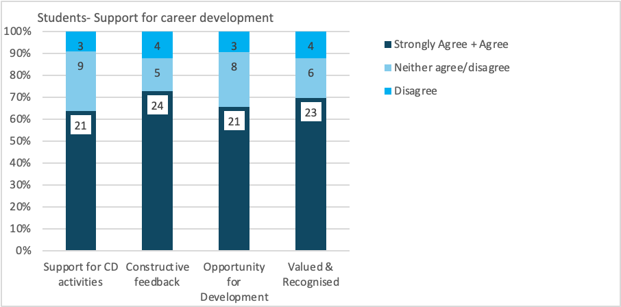

Appendix Figure 13. Percentage and head count of students responding positively to career development related questions in the student survey.

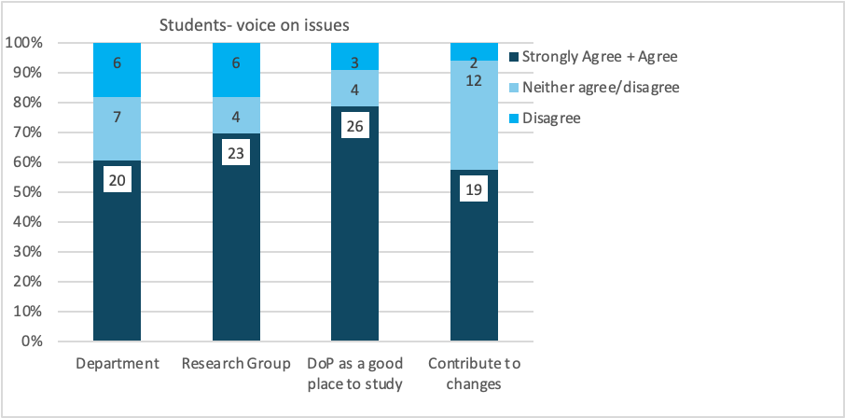

Appendix Figure 14. Percentage and head count of students responding positively to questions related to having voice on issues within their research groups and in the Department

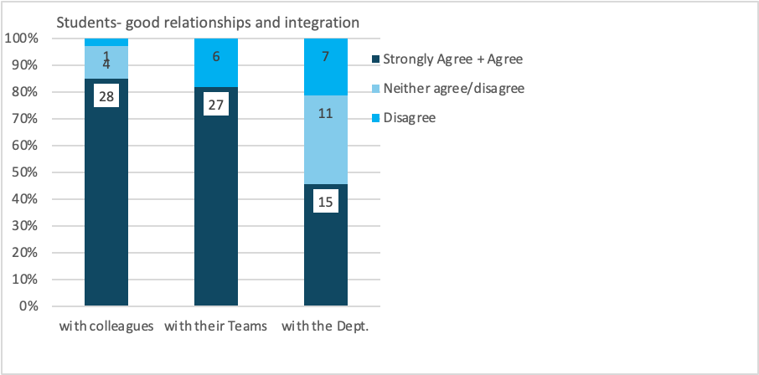

Appendix Figure 15. Percentage and head count of students responding positively to questions related to relationships with their colleagues, and integration with their teams and the Department

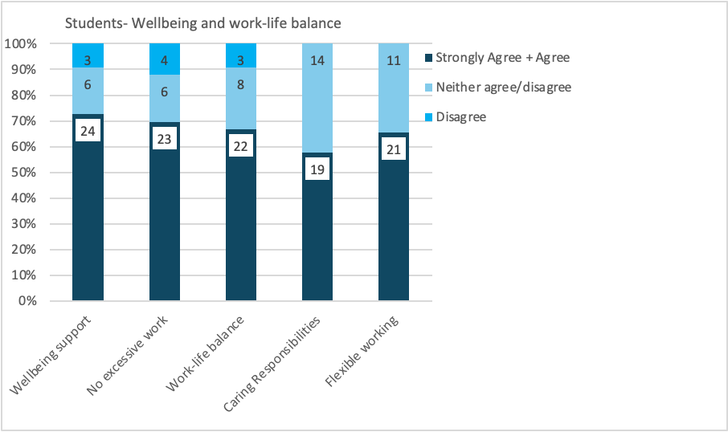

Appendix Figure 16. Percentage and head count of students responding positively to questions related to well-being, work-life balance and flexible working

Additional SES Questions
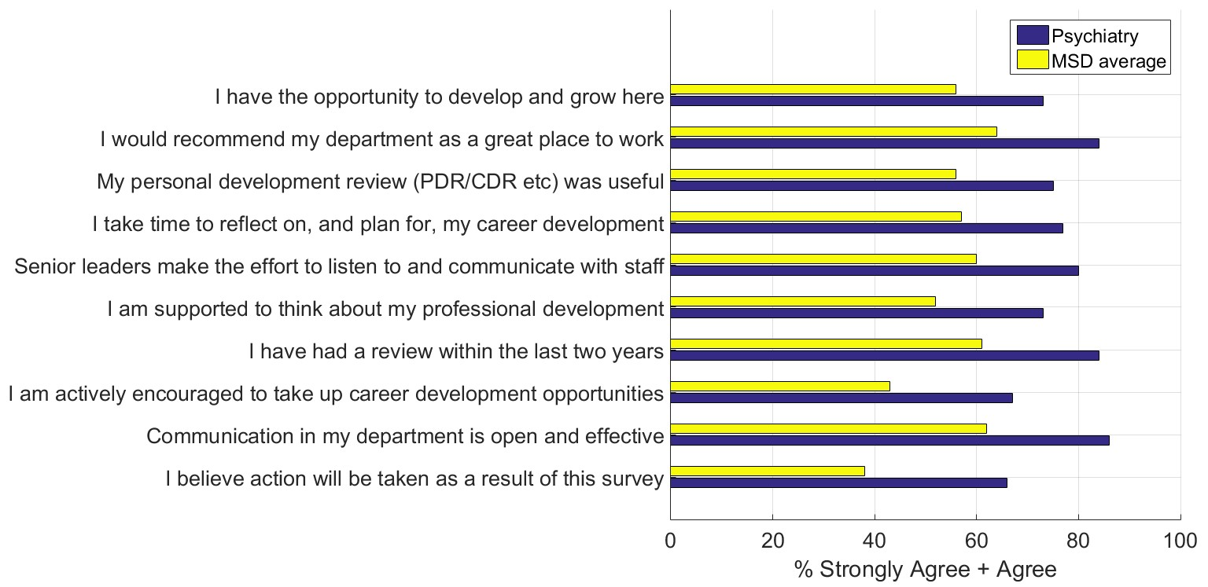
Appendix Figure 17. Top 10 survey items in which the Department of Psychiatry performed substantially above the Medical Sciences Division average in terms of positive ratings from staff
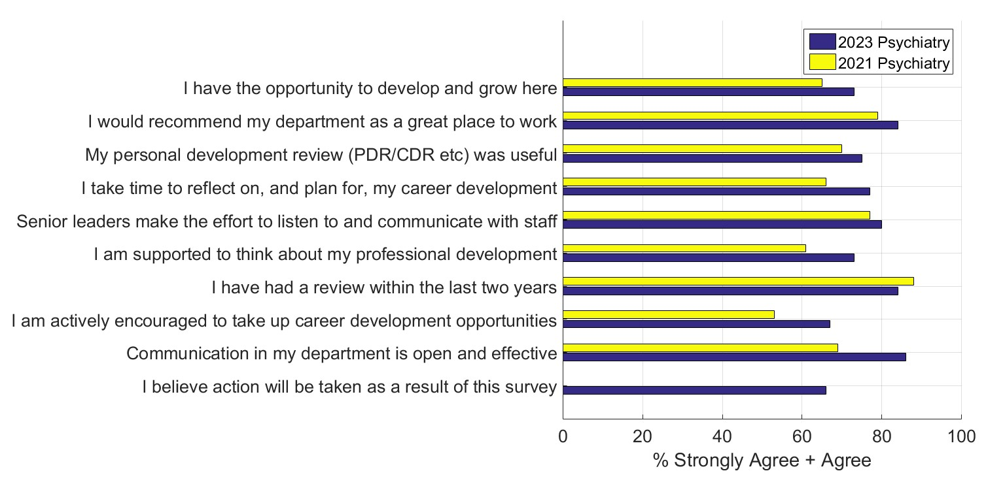Appendix Figure 18. Top 10 survey items from Appendix Figure 13 compared with staff ratings from 2021 survey.
Note that the final item “I believe action will be taken as a result of the survey” was not covered in 2021 staff survey, therefore one yellow bar of data is missing.

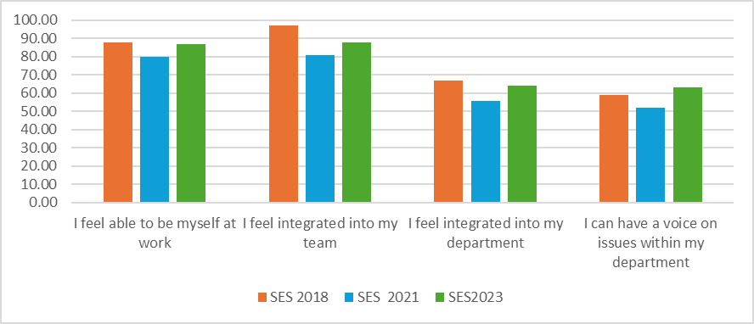
Appendix Figure 19: Comparison of SES results for rates of staff satisfaction pre and post COVID
Examples of COVID impact on staff reflections using 2021 results compared to 2018. Although 2022/2023 results are improved post-COVID they are not as positive as 2018.

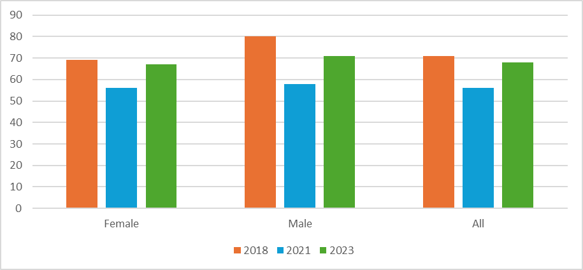

Appendix Figure 20: Survey Annual Comparison for Question: I feel included in my department's social/networking activities (% agreement with statement)

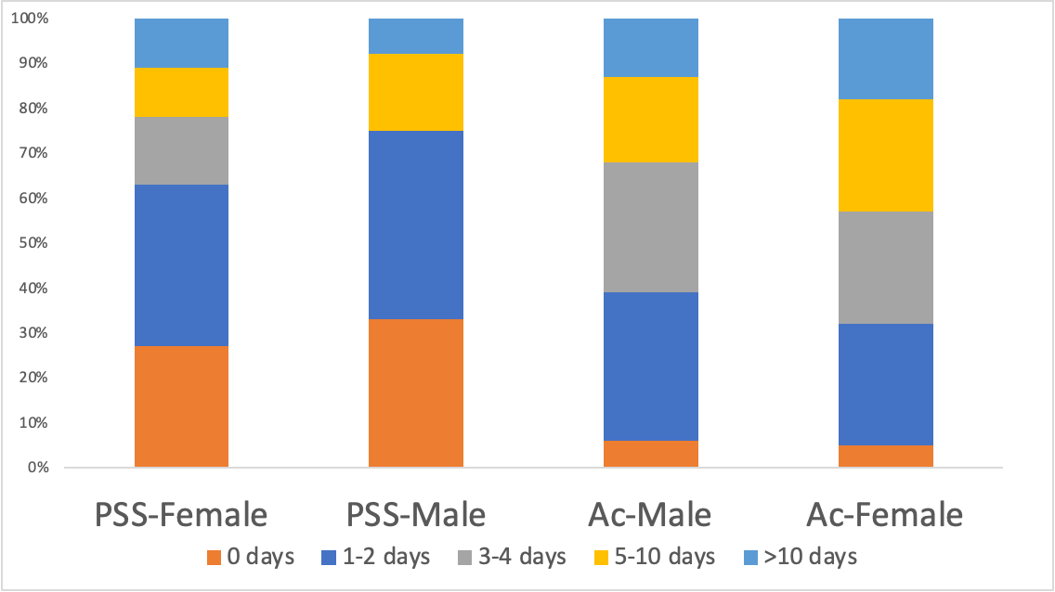

Appendix Figure 21: SES 2022/2023 focus – Total days spent on career development per working group.

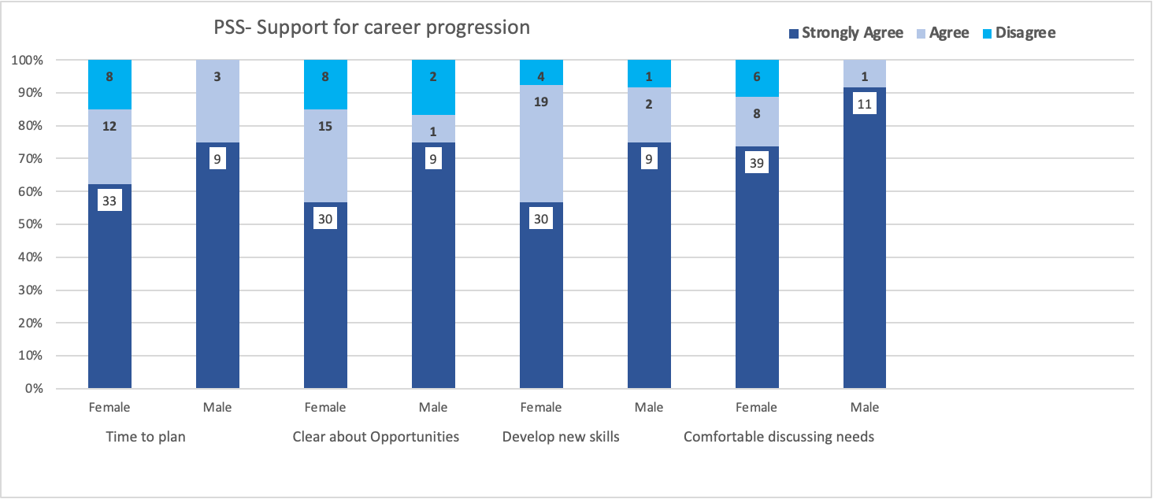
Appendix Figure 22: SES 2022/2023 focus - PSS staff support for career development

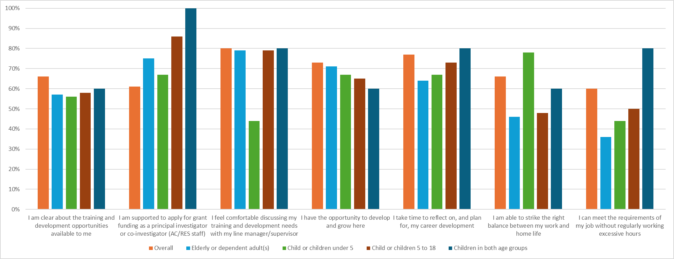
Appendix Figure 23: SES 2022/2023 focus – Staff with caring responsibilities reflections on career and workload

Appendix 2: Data tables
Please present the mandatory data tables, and if desired, any additional datasets.

Mandatory Data
Appendix 2 data redacted to avoid reidentification of staff members.

Department Data requirements | Figure Name
Students at foundation, UG, PGT and PGR level | Appendix Figure 24: Intake of students at PGT level (MSc Clinical and Therapeutic Neuroscience), by gender and year.
Students at foundation, UG, PGT and PGR level | Appendix Figure 25: Intake of students at PGR level (D.Phil Psychiatry), by gender, year, and full/part time.
Degree attainment and/or completion rates for students at foundation, UG, PGT and PGR level | Appendix Figure 26: Attainment rates for students at PGT level (MSc Clinical and Therapeutic Neuroscience), by gender and year.
 | Appendix Figure 27: Attainment rates for students at PGR level (D.Phil Psychiatry), by gender and year.
Academic staff by grade and contract function | Appendix Figure 28: All academic staff by grade and contract function including clinical
Academic staff by grade and contract function | Appendix Figure 29: Clinical Academic Staff
Academic staff by grade and contract function | Appendix Figure 30: Clinical Research Staff
Academic staff by grade and contract function | Appendix Figure 31: Research Staff
Academic staff by grade and contract type | Appendix Figure 32: All staff, including clinical by contract type
Professional, technical and operational (PTO) staff by grade and job family | Appendix Figure 33: Professional and Support staff by Job Family
PTO staff by grade and contract type | Appendix Figure 34: All staff, including clinical by contract type
Applications, shortlist and appointments made in recruitment to academic posts by grade | Appendix Figure 35: All Researcher/Academic Recruitment (including clinical)
Applications, shortlist and appointments made in recruitment to PTO posts by grade | Appendix Figure 36: All PSS Staff Recruitment
Applications and success rates for academic promotion by grade | Appendix Figure 37: Applications and success rates for full Professorial title
 | Appendix Figure 38. Applications and success rates for Associate Professor title
 | Appendix Figure 39: Research staff regraded and successfully applied to higher grade post
Applications and success rates for PTO progression by grade (where there are formal routes for progression) | Appendix Figure 40: Professional and Support Staff regraded and successfully applied to higher grade posts

Appendix 3: Glossary
Please provide a glossary of abbreviations and acronyms used in the application.
ACFs: Academic Clinical Fellow
AHoD: Associate Head of Department - PCC (People and Culture), R (Research)
AP: Associate Professor
AR: Academic Researchers
AS: Athena Swan
B&H: Bullying and Harassment
BME: Black and Minority Ethnic
BRC: Biomedical Research Centre
CDR: Career Development Review
CM: Communications Manager
DA: Departmental Administrator (now HAF)
DGS: Director of Graduate Studies
DPhil: Doctor of Philosophy
ECR: Early Career Researcher
EDI: Equality Diversity and Inclusion
FAP: Future Action Plan
FF: Family Friendly
FTC: Fixed Term Contract
GPG: Gender Pay Gap
HA: Harassment Advisors
HAF: Head of Administration and Finance
HCSL: Honorary Senior Clinical Lecturer
HoD Head of Department
HR: Human Resources
HRM: Human Resources Manager
LGBT(+): Lesbian, Gay, Bisexual and Trans
MSc: Master of Science
MSD: Medical Sciences Division
NHS: National Health Service
NIHR: National Institute for Health and Care Research
OE: Open Ended (Contract)
OLI: Oxford Learning Institute (now POD)
OH: Oxford Health (NHS Trust)
OUH: Oxford University Health Trust (OUH)
PCC: People and Culture Oversight Committee
PDR: Professional Development Review
PI: Principal Investigator
POD: People and Organisational Development
PAP: Previous Action Plan
PSS: Professional Support Staff
PT: Part Time
RAG rating: Red, Amber, Green rating
REF: Research Excellence Framework
RM: Research Manager
RoD: Recognition of Distinction
RS: Research Staff
SAT: Self-Assessment Team
SDF: Staff Development Fund
SES: Staff Experience Survey
SM: Success Measure
SMT: Senior Management Team
SPL: Shared Parental Leave
TAP: Titular Associate Professor
TP: Titular Professor
URL: University Research Lecturer
WGs: Working Groups
WICN: Women in Clinical Neurosciences Network

