5th – 7th Jan 2020
Copyright © Oxford University Images / Greg Smolonski

Oxford Short Course in
Experimental Medicine for Mental Health (OxCEMM)

This short course is run by the NIHR Oxford Health Biomedical Resea rch Cent re (BRC), and sponsored by the Wellcome Cent re for Integrati ve Neuroimaging (WIN).

Application now open
Click here or
Tap below to apply

Apply by
4th Oct 2019
OxCEMM is designed to provide a practical and comprehen sive grounding in experimental medicine for mental health for those with a basic understanding.
It is open to clinical and preclinical staff and trainees, medical doctors at any career stage. The course will be of inte rest to psychiatrists, neurologists, GPs and other specialists, nurses, basic scientists, allied health professionals and pharmacists.
Apply now, limited places and bursaries available. Bursaries will cover course costs including accommodation, evening and daytime meals as well as refreshment s.
Get in touch with any questions oxcemm@psych.ox.ac.uk
“ .. an intellectually stimulating course filled with inspirational content and pragmatic advice.
Course venue Warneford Hospital, Oxford. OX3 7JX
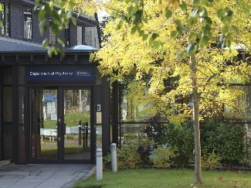
Copyright © Department of Psychiatry

Accommodation
St Anne’s College, 56 Woodstock Road, Oxford. OX2 6HS.

TAP HERE
OxCEMM 2019 participants

St Anne’s College, Oxford

OxCEMM course brochure Find us

