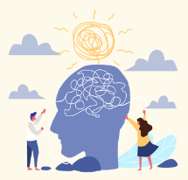
Participant Information Leaflet:
Personalised Care for Early Psychosis: the EXTEND study

What is the aim of the study?
The reason for this research is that we do not know what is the optimum time that people should remain in Early Intervention services.

This study is part of a larger programme of work which will help the research team make suggestions for the optimum time for the duration of Early Intervention services.

Why have I been invited?
We are contacting you as we believe you provide care for someone who is about to be discharged, or has recently been discharged from an Early Intervention in Psychosis service.

.
Who is leading the study: Professor Carolyn Chew-Graham
Keele University


What will happen to me if I take part, and what will I be asked to do?
You do not have to take part in this study. Participation is entirely voluntary.
You are also free to withdraw at any time during the interview and without giving any reason. If you agree to participate and then do not wish to continue, you will simply be able to let the researcher know this. You may withdraw your interview data up to four weeks after the date consent was provided (i.e. the date of your interview); this data will then be destroyed.

What does taking part involve?
You are invited to take part in an interview conducted by a researcher from Keele University. The interview will be held at a place and time convenient to you (e.g. at your home address, Keele University or other place; or by telephone or online platform – depending on your preference and COVID-19 restrictions.).
You will be asked to sign a consent form stating that you agree to take part in the study. This is to record that you have read this information sheet, understand what the research study is about, and that you agree to take part as described.
During the interview we will discuss your experience of the Early Intervention service, your views on the treatment of the person you care for provided by the Early Intervention service, and their experience of discharge. We will also discuss how the COVID-19 pandemic has affected the care provided to the person your support.
The researcher will ask you to share details of your General Practitioner so that if you do become distressed during the interview, the researcher can support you in contacting your GP.
With your permission, we will audio-record the interview and write this up for our analysis. We expect the interview to last around 45 minutes.
The recorded interview will be typed up by a professional transcribing company or the researcher who conducted the interview. The recorded interview will then be deleted after it has been typed up.

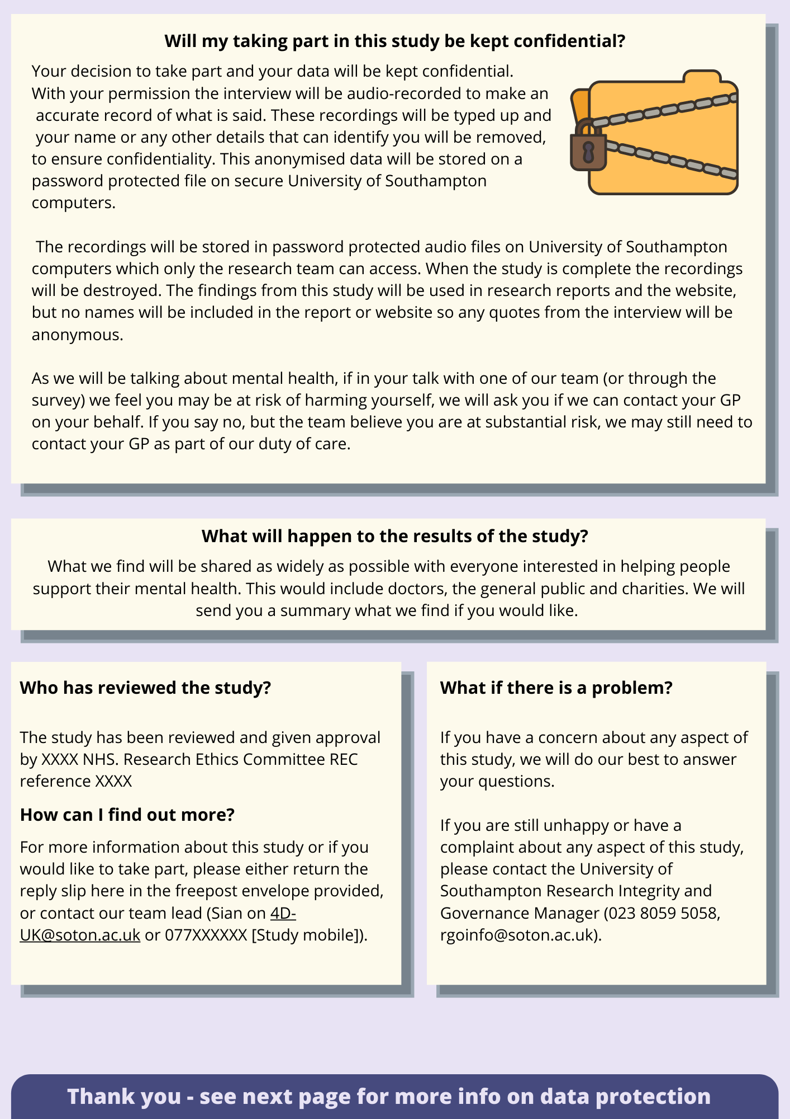


What are the possible advantages and disadvantages of taking part?

- What you think is very important to us  - Some individuals may find it helpful to talk through their experiences  - Your contribution will be valuable in enabling us to learn more about people’s experiences of Early intervention service and decisions made around discharge.  - We hope that the research will lead to an improvement to services in the future. | - Whilst there are no expected risks, some individuals may find talking about their personal experiences distressing.  - If during the interview you feel distressed or get upset, you can ask to take a break or end the interview.  - The researcher will provide information about services that you may wish to access (e.g. counselling services).

Who will have access to information about me?
How will we use information about you?
We will need to use information collected at interview for this research project.
This information will include your initials, name, contact details and information collected at interview. People will use this information to do the research or to check your records to make sure that the research is being done properly. People who do not need to know who you are will not be able to see your name or contact details. Your data will have a code number instead. We will keep all information about you safe and secure. Once we have finished the study, we will keep some of the data so we can check the results. We will write our reports in a way that no-one can work out that you took part in the study.

What are your choices about how your information is used?
- You can stop being part of the study at any time, without giving a reason, but we will keep information about you that we already have.
- We need to manage your records in specific ways for the research to be reliable. This means that we won’t be able to let you see or change the data we hold about you.

Where can you find out more about how your information is used?
You can find out more about how we use your information
- at www.hra.nhs.uk/information-about-patients/
- https://www.keele.ac.uk/legalgovernancecompliance/legalandinformationcompliance/informationgovernance/checkyourinformationisbeinghandledcorrectly/researchparticipants/
- by asking one of the research team
- by sending an email to dpo@keele.ac.uk

Will I be reimbursed for my time?
You will be offered a £25 shopping voucher to recompense your time.

Who will have access to information about me?
Prior to the interview, the researcher will request your written permission to audio-record the interview and transcribe it. The anonymised research data will be stored for 10 years.
Please note, in exceptional circumstances during the course of your participation in this research, where a research team member has any safety concerns about you or others the team may need to breach confidentiality to share these concerns with appropriate services.

What will happen to the results of the study?
We will write up what we find out from the interviews for a professional research journal so that the findings are shared with other academics and healthcare professionals. We also intend to present the findings at conferences that are open to members of the public and circulate summary reports to local voluntary organisations.
Your personal information will not be used in any of these documents or presentations.
This study is part of a larger programme which aims to improve the provision of care by Early Intervention services.
Who is funding the research?
This research project is funded by NIHR Programme for Applied Research.
Has the research been ethically approved?
Yes, this study has been ethically approved by the NHS and The North of Scotland (1) Research Ethics Committee.
Who do I contact if there is a problem?
To speak to the lead study supervisor, please contact:
Professor Carolyn Chew-Graham
School of Medicine, Keele University, ST5 5BG
Email: c.a.chew-graham@keele.ac.uk
Telephone: 01782 734 717
To make a complaint or speak to someone outside of the research team, please contact:

Directorate of Research, Innovation and Engagement
Innovation Centre Building 2, Keele University, ST5 5NH
Email: research.governance@keele.ac.uk
Telephone: 01782 733 371

If you have any concerns about the study, you can contact PALS:
https://www.nhs.uk/nhs-services/hospitals/what-is-pals-patient-advice-and-liaison-service/

For all other enquiries or to arrange an interview please contact:
The researcher, Michelle Rickett, at the School of Medicine, Keele University, ST5 5BG
Email: m.c.rickett1@keele.ac.uk

