Researching child – caregiver interactions

Scientists use observational coding to research the interaction between babies, or children, and caregivers. Behaviours and emotional states are classified and quantified using codes. The researcher observes or watches the interactions between a caregiver and a child and counts how often the different ‘codes’ take place.

The table below is an example of a record sheet that could be used to observe and record interactions between a child and a caregiver.

Your task:
- Have a go at filling in the table using the video link below.
- Use tally marks to count how many times each code happens in the video.
- You may need to pause the film often to be accurate in your observations.
- Repeat or compare your results to somebody else’s.
- What went well? What was harder?

Child-caregiver observation clip: https://youtu.be/06i61XcYY34

Observational code | Tally count (e.g.: )
Child shows interest in play using touch
Child shows interest in play using their voice
Child shows interest in play by looking
Child shows how they are feeling
Caregiver encourages child to play with an object
Caregiver labels/acknowledges child’s actions
Caregiver encourages child’s language (by repeating their words back to child)
Caregiver shows child they are interested in child’s play
Caregiver lets child lead the play
Caregiver builds on what the child’s doing or interested in
Caregiver responds to child’s feelings

What do the results show? Which codes had the most counts? Which had the least counts?

Can you use the results to suggest how the caregiver can improve their interactions with the child?

Researching child – caregiver interactions

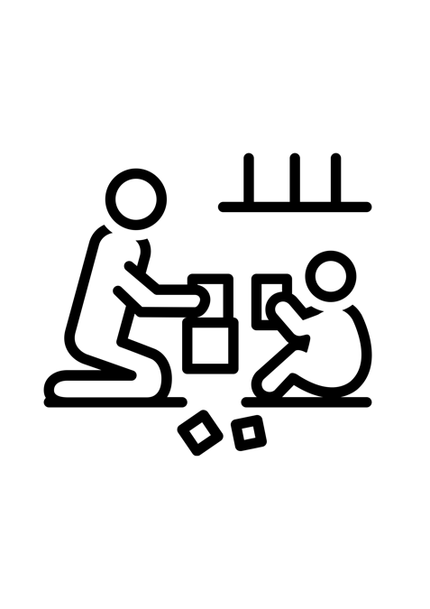
Scientists use observational coding to research the interaction between children and caregivers. Behaviours and emotional states are classified and quantified using codes. The researcher watches the film and counts how often the different ‘codes’ take place.

Below is an example of a record sheet.

Your task:
- Have a go at filling in the table using the video link below.
- Use tally marks to count how many times each code happens in the video.
- You may need to pause the film many times.
- What went well? What was harder?

Child-caregiver observation clip: https://youtu.be/06i61XcYY34

Observational code | Tally count (e.g.: )
Child shows interest in play using touch, voice or looking
Child shows how they are feeling
Caregiver encourages child to play with an object
Caregiver encourages child’s language (by repeating their words back to child or labelling actions)
Caregiver lets child lead the play
Caregiver builds on what the child’s doing or interested in
Caregiver responds to child’s feelings

Which codes had the most counts?

Which had the least counts?

In your opinion, what can the caregiver do more of?

