Brain development

- Which two factors influence brain development?

- What are brain cells called?

- What causes the strengthening of connections and circuits?

- What happens to connections that are not used?

- What type of circuits are formed in the early years?

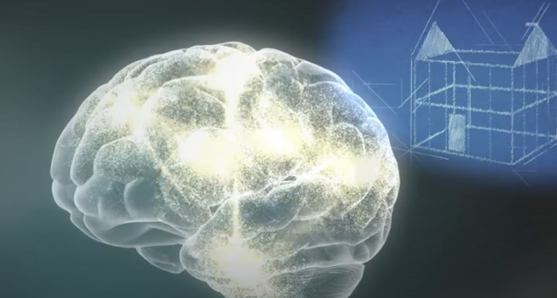
The video compares a baby’s brain to the foundations of a house.
How are they similar?
Hint:
What are foundations of a house? What are they for? When are they built?

Write your ideas below:

