Brain development

- Which two factors influence brain development?

- What are brain cells called?

- What causes the strengthening of connections and circuits?

- What happens to connections that are not used?

- What type of circuits are formed in the early years?

Look at the diagram below. It shows neurons connecting together at synapses (junctions).

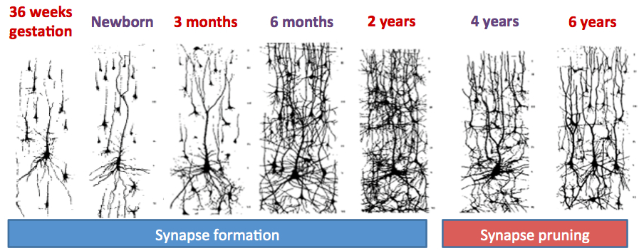
Describe what you see:

In your own words, describe what is happening in a child’s brain from being in the uterus until age 6 years:

Challenge task:
The video uses the analogy of house building to describe brain development. How would you explain this to somebody who hasn’t watched the film? When you are ready, try it out on the person next to you.
Or have a go explaining it to a member of your family when you get home!

