Epigenetics and the role of the caregiver.

Weaver et al (2004) investigated the effects of different mothering behaviours in rats on the stress response of offspring. Rat mothers show different parenting styles. Some show high quality mothering behaviours (e.g. licking, grooming, arching the back whilst the pups feed). Others do not show this high quality caring behaviour.
Scientists found that the offspring of mothers with high levels of caring behaviours were less fearful and had reduced biological stress responses. Scientists knew that it was about the quality of care, since pups were with the rat mothers for the same amount of time for both styles.
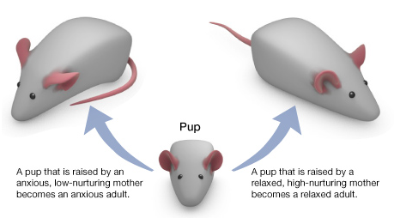
The biological stress response is controlled by the hypothalamic-pituitary-adrenal or ‘HPA’ axis. It is responsible for the release of the hormone cortisol. The stress response is regulated by genes being switched on and off.
The study used a ‘cross fostering’ method to work out whether these differences were passed down from mother to pup via DNA. Did the mothers who displayed high levels of parenting behaviour just pass down their “good genes” to the pups?
Mothers with high caring behaviours were given pups from mothers without these behaviours, and vice versa. Scientists noticed that the pups fostered by mothers with caring behaviours showed the same benefits later in life as their foster mother’s biological pups who they were being raised with.
Whether a pup grows up to be anxious or relaxed depends on the mother that raises it – not the mother that gives birth to it. Source: https://learn.genetics.utah.edu/content/epigenetics/rats/

The scientists concluded that the biological differences were not the result of pups’ DNA code passed down from their biological mother but caused by their foster mothers’ behaviours. The interactions with the mother were switching on and off the genes that control the HPA axis. This mechanism of the environment causing changes in how the genes work is called epigenetics.
Questions:
- What was the independent variable in Weaver et al’s investigation?
- What were they measuring as an outcome (their dependent variable?)
- What was the evidence that the outcomes were not caused solely by genetic factors?
- What is epigenetics?
- How does this relate to what you have been learning about the role of caregivers?
- Find out more about how epigenetics affects child development by reading:
https://46y5eh11fhgw3ve3ytpwxt9r-wpengine.netdna-ssl.com/wp-content/uploads/2019/02/EpigeneticsInfographic_FINAL.pdf

