SEEN – Secondary Education around Early Neurodevelopment.
Lesson 2: Full instructions for students completing the lesson.

Watch the pre-recorded lesson by following the link given below. All links and file names will also be given on this document (as you cannot click on them from the video).

Enjoy!

- Open the lesson video at: https://youtu.be/QJL-xcKa0mk
Watch the introduction.

- What do caregivers do to promote healthy development from conception (start of pregnancy) to age 5? Note your ideas down here:

- Optional video to watch: https://www.youtube.com/watch?v=k1hNZhH9bRg

- Listen to an explanation of why the early years are important and watch the videos. The links are given again below in case you want to watch the clip in your own time. Note down the main learning points under each video link:

Serve and return interactions:
https://www.albertafamilywellness.org/resources/video/serve-and-return

Baby talk:
https://www.unicef.org/parenting/child-development/baby-talk-class

Playful learning:
https://vimeo.com/505601316/cde3ca6023

Executive function and self-regulation
https://www.albertafamilywellness.org/resources/video/executive-function

- You have a choice of activities here (unless your teacher has specified what to do). The pre-recorded lesson will take you through activity ‘a’ – child observation of playful learning. Activity b and c can be completed using the relevant worksheets (ask your teacher).
  - Child observation worksheet (learning through play – see below)
  - 10 top tips for caregivers
  - Public health leaflet

Learning through play 1

A good way to develop the skills of a responsive caregiver is to imagine what the child is thinking. This worksheet asks you to practise this.

Watch the clip of Iris with her sister Lyra (40s). Imagine what thoughts are in Lyra’s head (the baby) https://youtu.be/1MHTil5QRf8

EXAMPLE: What is Lyra (the baby) thinking 3 seconds into the clip?
(Hint: It is important to watch the clip to understand what has happened before and after, rather than just guessing from the picture.)
Ooooh, I want to see what’s on the next page!
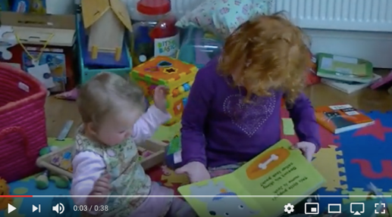

Your turn! What is Lyra thinking? Write your idea in the thought bubble.

11 seconds
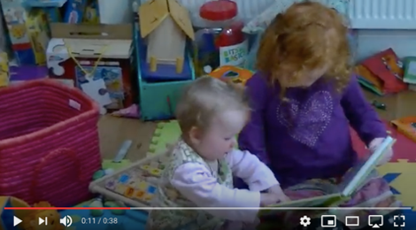

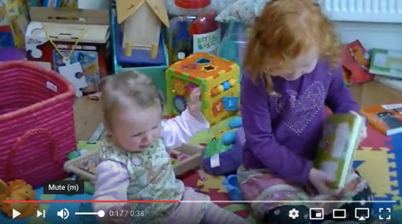

17 seconds
33 seconds
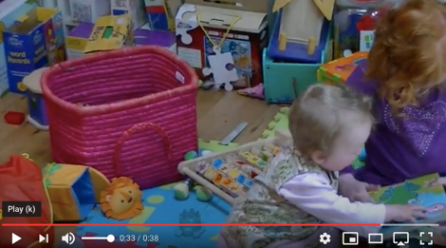

What advice would you give Iris?

- What have you learnt? Take some time to reflect on today’s lesson. What will you do differently next time you interact with a baby or child under 5? See if you can think of 3 things...
Complete the sentence below:

“Next time I see a baby or young child I will…
1)

2)

3)

