Learning through play 1

A good way to develop the skills of a responsive caregiver is to imagine what the child is thinking. This worksheet asks you to practise this.

Watch the clip of Iris with her sister Lyra (40s). Imagine what thoughts are in Lyra’s head (the baby) https://youtu.be/1MHTil5QRf8

EXAMPLE: What is Lyra (the baby) thinking 3 seconds into the clip?
(Hint: It is important to watch the clip to understand what has happened before and after, rather than just guessing from the picture.)
Ooooh, I want to see what’s on the next page!
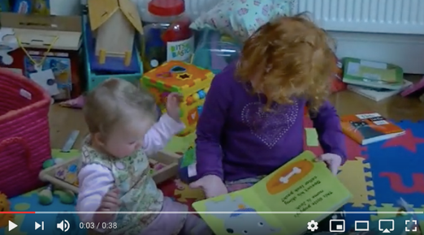

Your turn! What is Lyra thinking? Write your idea in the thought bubble.

11 seconds
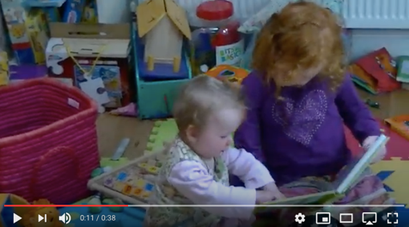

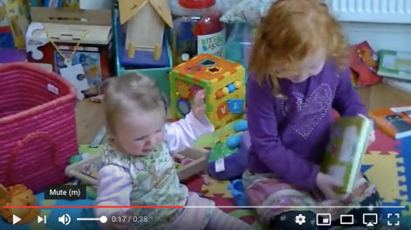

17 seconds

33 seconds
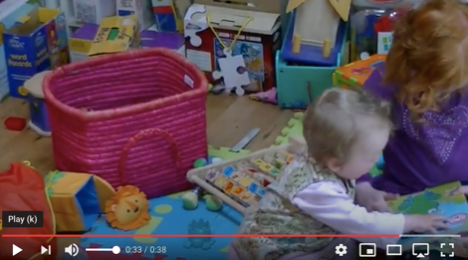

What advice would you give Iris?

