Learning through play 2 - answers

Watch the clip: https://vimeo.com/user9052202/review/508335899/a8b43538e9.

There are no strict right and wrong answers to these “getting into the mind of the child” activities. However, the following are some suggestions based on what is happening at, and around, the time of the freeze-frame.

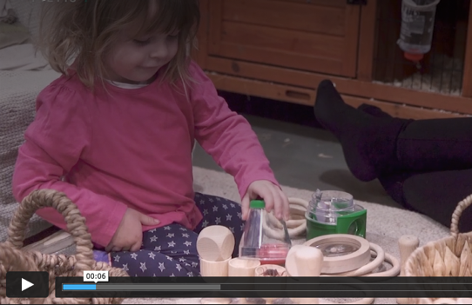
6 seconds
“I wonder what will happen if I put this on here. Hmm, its doesn’t fit.”

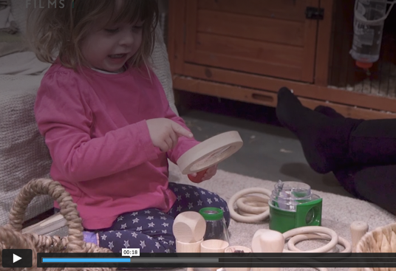
“Look at that! The spider has got really big. I wonder how that happened”
18 seconds
“My finger is big too. It feels weird to move it around. I can make my finger big and small and watch it move.”
42 seconds
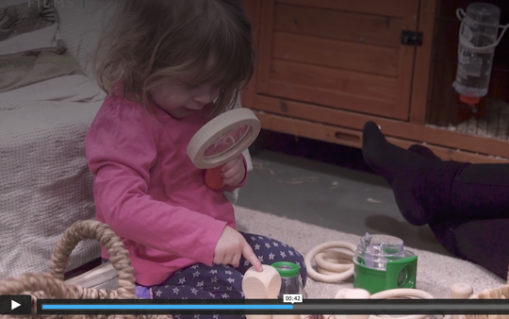

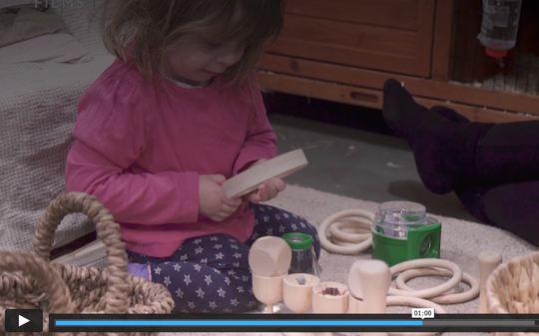
1 minute
“I think it is making things big when I look through. Does it work with this? Let me see.”

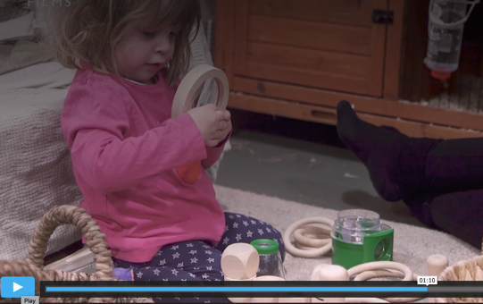
“Does it get bigger if I put it closer? Or does it get smaller? Does it look different? Maybe if I lift it up…”
1 minute 10
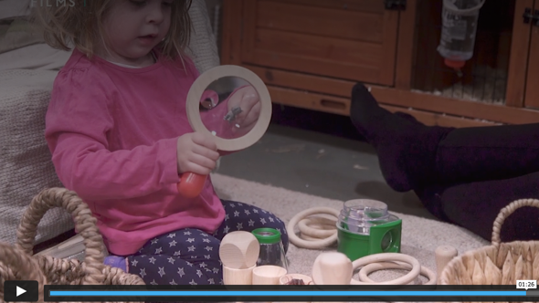
“Does it work the other way round. If I put it in front of the glass, what happens?”
1 minute 26

How is the caregiver supporting playful learning?

The caregiver is:
- Sitting back and letting the child explore with the equipment how the child wants to.
- In a safe environment.
- Responding to the child, repeating words to show she is interested in her and extends vocabulary (e.g. ‘magnifier’)
- Shows she is curious about, and attentive to, the play by responding to the child’s comments.
- Uses a sing song voice e.g. “It’s big now?”

What else can the caregiver do to support the child’s development?
- Extend play through suggestions that respond to the child’s interest.
- Could get involved in the play (although it is also ok to sit back whilst still being attentive).
The caregiver here is doing a great job – is clearly attentive and responsive, whilst giving the child enough space to play independently.

