Learning through play 2
Watch the clip: https://vimeo.com/user9052202/review/508335899/a8b43538e9.

TASK: Fill in the thought bubbles with what you imagine the child is thinking at the time of each ‘freeze-frame’. (The time in the video has been given for you so you can rewatch that part of the clip).

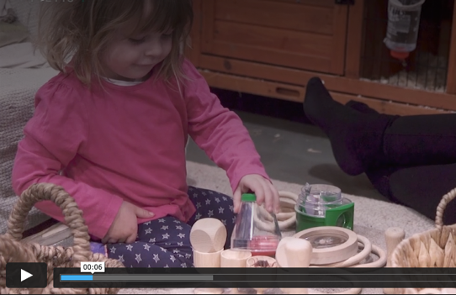
6 seconds

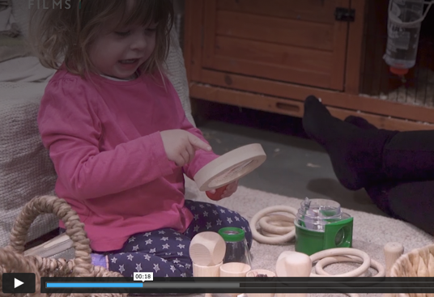
18 seconds

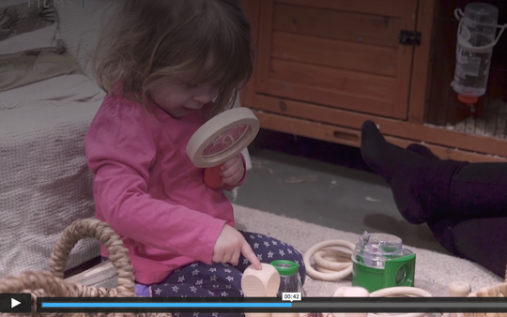

42 seconds

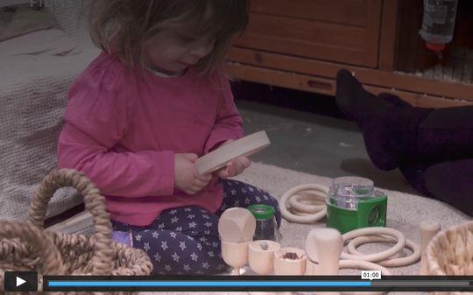
1 minute

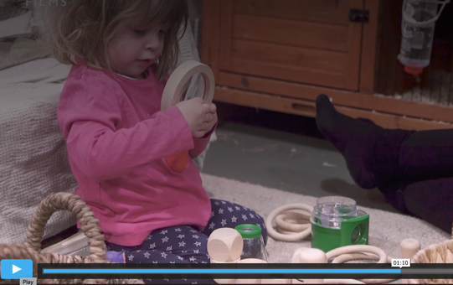
1 minute 10

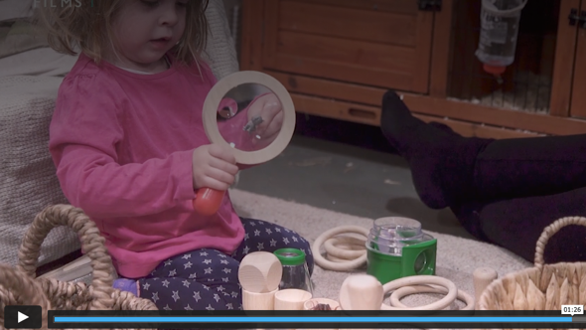

1 minute 26

How is the caregiver supporting playful learning?

What else can the caregiver do to support the child’s development?

