SEEN – Secondary Education around Early Neurodevelopment.
Lesson 3: Full instructions for students completing the lesson.

Watch the pre-recorded lesson by following the link given below. All links and file names will also be given on this document (as you cannot click on them from the video). The pre-recorded lesson will guide you through this student lesson sheet.

Enjoy!

- Open the lesson 3 video at: https://youtu.be/9ubzXpKZhBs
Watch the introduction.

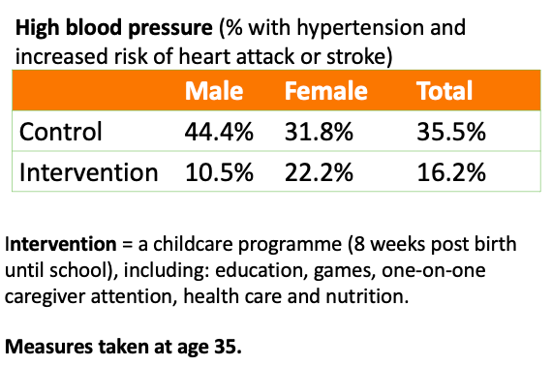
- The early years are a foundation for long term health outcomes. The pre-recorded lesson will introduce the ABC study, a research project that collected evidence to support this claim. Listen to an explanation of the study and then pause it while you complete the following questions. Return to the lesson recording to mark your work.

- What do the results tell you about the impact of early years on adult health?

- What do you think is meant by a longitudinal study?

- What is a control?

- Watch the video on Brains: journey to resilience (7.44)
https://www.albertafamilywellness.org/resources/video/brains-journey-to-resilience

- Answer the following questions using what you learnt in the video (you can watch parts of the video again to help).
- What factors affect brain development?

- What is meant by toxic stress?

- What is meant by resilience? What can we do to help to build resilience?

- When are the brain’s two main periods of sensitivity to experience?

- Return to the recorded lesson to check your work.

- Complete the end of lessons quiz and evaluation using the following link:
https://oxford.onlinesurveys.ac.uk/pre-pilot-pupil-survey-post-lesson-
Remember, if you don’t know the answer, that is ok, just choose “I don’t know”.
The more feedback you can give us on the lessons the better!

