Stress and the brain

Flow chart showing the stress response:
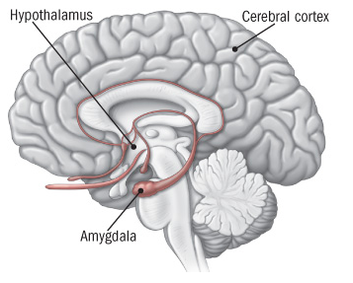
The stress response begins in the brain with the amygdala and hypothalamus triggering hormone release.
External stress event
Stress related hormones released (adrenalin and cortisol)
Brain initiates stress response
(amygdala and hypothalamus)
Body and behaviour changes in response e.g. increased heart and breathing rate
Body and behaviour return to normal
External stress event is removed
Positive or short-term stress
External stress event remains long term
Long term impact on body and brain leading to health problems
Long-term stress
Stress and early brain development.
The brain grows fastest from conception (in the mother’s uterus) until about 2 years. It remains very sensitive to the environment until about 5 years. Prolonged stressful events in the child’s life can have an impact on the developing brain.

Questions:

- Which parts of the brain are involved in the stress response?

- A hormone is a chemical messenger in the body. Name a hormone related to stress in the body.

- The flow chart gives examples of what happens in the body when it is stressed.
  - What examples are given?
  - Can you think of other changes that happen in the body when somebody is stressed?

- The flow chart distinguishes between short term and long term stress. What is the difference according to the diagram?

- Can you suggest an example of when stress is helpful?

- Discuss the role of stress in early neurodevelopment (0-5 years). What might cause a baby or young child stress? How can a caregiver reduce the impact of stress?

